Wound-Splat: An AI-Driven Smartphone-Based 3D Reconstruction and Wound Assessment Framework for Diabetic Foot Ulcer Monitoring

Angeles, Joseph B., Flores, Renz Ken T., Lapid, Darwin G., Pasagdan, Renz Rainier L.
Department of Computer Science, Technological Institute of the Philippines
CS 307: Thesis 1
Ms. Elsa I. Barcelos
October 2026

Table of Contents
CHAPTER 1 Introduction 8
Background of the Study 9
Objectives of the Study 12
Significance of the Study 14
Scope and Delimitations 15
Scope 15
Delimitation 17
CHAPTER 2 Review of Related Literature 18
Theoretical Foundations of the Framework 19
Conceptual Framework 20
Research Paradigm 22
Flowcharts 23
Review of Related Literature 27
Clinical Significance of Diabetic Foot Ulcers 27
Conventional Wound Measurement and Digital Monitoring 28
Clinical Classification Systems for Diabetic Foot Ulcers 29
Smartphone-Based Photogrammetry and Volumetric Analysis 31
Structure from Motion, Multi-View Stereo, and COLMAP 32
Neural Radiance Fields and 3D Gaussian Splatting 33
Surface Reconstruction and Geometric Wound Measurement 35
Deep Learning for Wound Segmentation and Tissue Characterization 36
Datasets, Benchmarks, and Validation 39
Longitudinal Monitoring and Three-Dimensional Registration 40
GPU Acceleration and Client–Server Architecture 41
Software Product Quality, Usability, and Clinical Interpretability 42
Synthesis and Research Gap 43
Definition of Terms 46
CHAPTER 3 Methodology 49
Project Materials 49
Software 50
Hardware 54
Dataset 55
Data Sources 58
Data collection 59
Project Design 61
System Architecture 61
Processing Pipeline Design 64
Database DesignFigure 9: Database Entity Relationship Diagram 67
Project Development 70
Development Model 70
Multiple Constraints and Trade-off Analysis 75
Constraint Definition 75
Design Trade-offs 80
Trade-off Analysis 84
Sensitivity Analysis 87
Testing and Operating Procedure 91
Project Evaluation 91
Survey Questionnaire for Non-Information Technology Respondents 94
Survey Questionnaire for Non-Information Technology Respondents 97
Work Plan 100
Potential for Commercialization 101
Market Model 102
Measurable Benefits 102
Three-year Product Roadmap 103
Go-to Market Strategy 104
Business Model 105
References 107

List of Tables
Table 1: System-Level Toolchain 50
Table 2: Backend Dependencies 52
Table 3: Frontend Dependencies 53
Table 4: Tissue-Model Training Environment 54
Table 5: Computing Hardware 55
Table 6: Composition of DFUTissue Dataset 56
Table 7: Data Sources and Purpose 58
Table 8: Comparison of Three-Dimensional Reconstruction Methods 82
Table 9: Comparison of Geometric Measurement Representations 83
Table 11: Evaluation Criteria for the Trade-Off Analysis 86
Table 12: Criterion Weights for the Sensitivity-Analysis Trials 89
Table 13: Three-year Roadmap Table 104

List of Figures
Figure 1 Wound-Splat Input–Process–Output Model 21
Figure 2: Wound Scan Processing and 3D Reconstruction Workflow 23
Figure 3: Patient Registration Workflow 24
Figure 4: Patient-Code Access Workflow 25
Figure 5: Wound Tissue Analysis Workflow 26
Figure 6: DFUTissue sample 57
Figure 7: Wound-Splat System Architecture 62
Figure 8: Seven-Stage Processing Pipeline 65
Figure 10: Iterative Development Model Applied to Wound-Splat 72
Figure 11 Work Plan Gantt Chart for Thesis 1 and Thesis 2 101
Figure 12: TAM SAM SOM Model 102
Figure 13: Go-to Market Strategy 105
Figure 14: Business Model Canvas 106

List of Equations

CHAPTER 1 Introduction
Three-dimensional reconstruction from two-dimensional imagery has advanced through methods such as 3D Gaussian Splatting (3DGS), which represents a scene using optimized Gaussian primitives and supports interactive rendering after training. Rendering speed must be distinguished from the time required to reconstruct a scene. This study develops Wound-Splat, a framework that combines Structure from Motion and an existing 3DGS implementation to reconstruct wound-like geometry from standard smartphone videos and estimate geometric measurements for diabetic foot ulcer assessment support. The study investigates technical feasibility and measurement limitations rather than establishing diagnostic performance.
The implemented framework combines three-dimensional wound isolation and measurement with a separate two-dimensional tissue-characterization module. Wound isolation operates on the reconstructed point cloud, whereas tissue characterization estimates fibrin, granulation, and callus within an operator-selected region of a video frame. Longitudinal registration across visits and evidence-based Wagner and University of Texas classification support remain planned components under Objectives 2 and 3. Their implementation and evaluation must be distinguished from the features already available. The system uses a client-server architecture: the browser handles uploads and result viewing, while an NVIDIA GPU-equipped backend performs reconstruction. Capture instructions remain necessary to obtain suitable videos.

Background of the Study
Diabetes is a major public health concern in the Philippines, with approximately 1 in 14 Filipino adults diagnosed with the condition (International Diabetes Federation, 2024). Among its most debilitating complications is the diabetic foot ulcer (DFU), which, if not properly monitored, often leads to lower-limb amputation. Globally, DFUs affect approximately 18.6 million people each year and precede 80% of lower extremity amputations in diabetic patients. The five-year mortality rate for a patient with a DFU is approximately 30%, rising to over 70% for those who undergo major amputation.
Currently, many clinics rely on 2D photography and manual ruler measurements to track wound healing. These methods, however, fail to capture volumetric depth, which is a critical indicator of wound healing or deterioration. A recent retrospective study of 101 DFUs undergoing negative pressure wound therapy (NPWT) found that volume change velocity peaked at 1.20 cm³/day within two weeks of treatment (p = 0.001), demonstrating that 3D wound assessment can effectively predict healing outcomes (Flaherty et al., 2024). While professional 3D medical scanners exist, their prohibitive cost prevents deployment in low-resource settings. Moreover, traditional photogrammetry techniques are computationally heavy and lack real-time capabilities.
Recent breakthroughs in 3D Gaussian Splatting (3DGS) have demonstrated that millions of 3D Gaussians can be optimized and rasterized in real time using CUDA-based parallelism. A comparative evaluation of NeRF, Gaussian Splatting, and SfM-MVS using low-cost sensors found that NeRF and Gaussian Splatting significantly outperformed SfM-MVS in processing time, with Gaussian Splatting offering efficient and rapid 3D modeling (Clini et al., 2024). Several smartphone-based applications currently exist for DFU assessment, such as imitoWound and Minuteful for Wound. However, a systematic evaluation of wound assessment apps revealed that most apps available in major app stores do not meet the overall requirements for effective wound monitoring, with many lacking sufficient evidence-based reliability (Kabir et al., 2024). Notably, even apps that claim 3D measurement capabilities have shown only fair agreement for volume measurements compared to reference devices, and none leverage 3D Gaussian Splatting for volumetric reconstruction.
Recent advances in wound imaging research highlight both the potential and the challenges of 3D reconstruction. The SALVE benchmark (Chierchia et al., 2025a) provided the first comprehensive evaluation of reconstruction methods on wound phantoms, finding that while neural rendering approaches show promise, photogrammetry approaches do not provide smooth surfaces suitable for precise clinical measurements. Wound3DAssist (Chierchia et al., 2025b) demonstrated that millimeter-level accuracy is achievable from smartphone videos, but at the cost of requiring server-grade hardware and extended processing time. Meanwhile, lightweight optimization frameworks like LiteGS (Liao et al., 2025) have shown that 3DGS training can be accelerated by up to 13.4x with minimal quality loss, suggesting a path toward consumer-grade deployment. WoundNeRF (Chierchia et al., 2026) further advanced the field by learning 3D-consistent semantic fields directly from multi-view images, outperforming traditional 2D segmentation methods, though remaining computationally intensive.
Image segmentation is a critical step in automated DFU analysis, serving as the bridge between raw 2D images and clinically meaningful 3D measurements. Accurate Segmentation is essential for isolating the wound boundary and classifying tissue types such as granulation and fibrin, granulation, and callus, which provide key indicators of healing or deterioration. Deep learning has significantly advanced wound segmentation, with architectures such as HarDNet-MSEG combined with the Segment Anything Model (SAM) achieving an average Dice of 83.44% on the DFUC 2022 dataset (Chen et al., 2023). Public datasets and challenges such as DFUC 2022, DFUC 2023, and DFUC 2024 have driven progress by providing standardized benchmarks for algorithm comparison. While most research focuses on 2D segmentation, recent work on WoundNeRF has explored 3D-consistent segmentation from multi-view images using Neural Radiance Fields (Chierchia et al., 2026). For the Wound-Splat framework, the wound region is isolated from the reconstructed point cloud, while a trained network characterizes tissue type on selected frames.
To address these issues, the proposed Wound-Splat framework aims to provide a comprehensive method for 3D volumetric analysis of diabetic foot ulcers using only standard smartphone videos and existing GPU-accelerated 3D Gaussian Splatting implementations. Unlike existing approaches, the framework integrates 3D reconstruction with 2D wound segmentation for tissue characterization, supports longitudinal monitoring through 3D model registration across visits, and maps measurements to established DFU classification systems (Wagner, University of Texas) for clinically interpretable outputs. While the system requires a GPU-equipped workstation for reconstruction, this is still a fraction of the cost of a professional medical 3D scanner and can be centrally deployed in a hospital IT department rather than purchased per clinic. The application handles video upload and result viewing, making the system accessible without requiring specialized training.

Objectives of the Study
The primary goal of this research is to design, develop, and validate a smartphone-based 3D reconstruction framework for diabetic foot ulcer monitoring. Specifically, this study aims to:
- Implement a 3D reconstruction pipeline utilizing Structure from Motion (SfM) and stock 3D Gaussian Splatting (3DGS) to accurately extract volumetric DFU models from smartphone videos.
- Design a temporal tracking module utilizing geometric registration algorithms to align 3D models across visits, automating the calculation of wound volume changes over time.
- Automate the extraction of spatial metrics (depth, volume, area) to programmatically map 3D reconstruction outputs to established Wagner and University of Texas classification systems.
- Develop and evaluate a client-server web application using Next.js and FastAPI for GPU-delegated 3DGS processing, validating algorithmic accuracy with simulated models and assessing overall software quality utilizing the ISO/IEC 25010 Model.

Significance of the Study
This research contributes to the growing body of knowledge on the application of 3D reconstruction techniques to medical imaging, specifically in the context of diabetic foot ulcer monitoring. While 3D Gaussian Splatting (3DGS) has demonstrated promise in general 3D reconstruction tasks, its application to wound assessment remains underexplored. The SALVE benchmark (Chierchia et al., 2025a) identified that existing photogrammetry methods fail to provide smooth surfaces suitable for clinical measurements, and neural rendering approaches like 3DGS show promise but have not been systematically evaluated for wound monitoring. This study addresses that gap by investigating the feasibility of using 3DGS for DFU reconstruction from smartphone video.
Furthermore, the integration of 3D reconstruction measurements with established DFU classification systems (Wagner, University of Texas) represents a novel contribution. While these classification systems are widely used in clinical practice, they have traditionally relied on manual measurement and visual assessment. By mapping automated 3D measurements to these systems, this research explores how computer vision can bridge the gap between technical reconstruction and clinical utility.
The primary beneficiaries of the research would be diabetic patients, who could directly upload videos through a mobile or web interface and receive 3D wound assessments without requiring specialized clinic visits; Healthcare professionals, who could obtain objective 3D measurements (volume, depth, area) to support clinical decision-making; Hospitals and specialty clinics, which could perform volumetric wound analysis without the need for dedicated medical 3D scanners; and researchers in computer vision and medical imaging, who could build upon the framework and findings presented in this study. The methodology for 3D wound reconstruction, longitudinal monitoring, and classification integration may inform future work in wound assessment and related medical imaging applications.

Scope and Delimitations

Scope
This study covers the design, development, and initial validation of the Wound-Splat framework, a smartphone-based 3D reconstruction system for diabetic foot ulcer monitoring using existing 3D Gaussian Splatting (3DGS) implementations.
The scope encompasses the entire pipeline from video capture to clinical output – a Structure from Motion (SfM) pipeline for camera pose estimation and sparse point cloud generation, followed by 3DGS-based dense reconstruction, image wound segmentation, comparison of 3D models from multiple patient visits to document wound change over time, and the mapping of all measured parameters to a rule-based classification based on established DFU classification systems (Wagner, University of Texas) to produce clinically interpretable outputs. An absolute scale is obtained from a reference object of known size placed beside the wound during capture. The system detects a standard bank card or coin in the video frames and derives the number of centimeters represented by one unit of the reconstructed model. Where no reference object is detected, measurements are reported as uncalibrated and flagged as approximate rather than presented as clinical values. The framework’s output is a clinically useful report containing measurements, classifications, and change-over-time visualizations to support clinical decision-making. Moreover, validation will be based on simulated wound models with verifiable baseline measurements. Moreover, validation will be based on synthetic wound phantoms with analytically known dimensions so that measured values can be compared against exact ground truth. This follows the principle of phantom-based evaluation used in the SALVE benchmark (Chierchia et al., 2025a), which employed physical rather than synthetic phantoms. Lastly, the framework will be implemented on a web or mobile application for video upload and result viewing, following a client-server architecture model where reconstruction and segmentation processing occurs on a backend GPU workstation. The framework is delivered as a web application with two user roles. A patient portal allows a patient to sign in with an assigned code, upload a wound video, follow processing status, and view the resulting model and report. A clinical administration view allows staff to register patients and monitor the processing queue. Completed scans can be inspected in an interactive three-dimensional viewer in the browser, and the measurements are compiled into a generated PDF report.
Processing runs as a fixed seven-stage pipeline: frame extraction, camera-pose estimation, 3DGS optimization, preview rendering, wound isolation, scale calibration and measurement, and report generation. Each stage reports progress so that a scan in process can be monitored rather than appearing unresponsive. A complete scan takes approximately thirty to sixty minutes on a single consumer GPU.

Delimitation
The framework is subject to several delimitations. The study utilizes existing open-source libraries and models for implementing the algorithms used within the framework; the contribution lies in the application, integration, and evaluation of these latest methods for DFU monitoring. Validation is limited to phantom-based evaluation using simulated wound models and geometric objects; clinical validation with real patient data is outside the study scope. Reconstruction is evaluated using smartphone-captured video under controlled lighting conditions, and the framework is not validated for uncontrolled environments or varying lighting. The system is designed for a single NVIDIA RTX series GPU, and cloud or distributed computing is not included. The system does not include integration with electronic medical records to existing clinics. Classification suggestions are based on identified tissue types present in the wound and geometric measurements – the framework does not assess infection, ischemia, or other clinical factors that are part of complete classification systems. Factors such as skin temperature and blood flow, which are important clinical indicators, cannot be captured through standard RGB video and are not measured by the framework.

CHAPTER 2 Review of Related Literature
This chapter presents the theoretical, clinical, and technological foundations of the Wound-Splat framework. The proposed system addresses the monitoring of diabetic foot ulcers (DFUs) through smartphone video, computer vision, three-dimensional reconstruction, wound segmentation, geometric measurement, and longitudinal comparison. The review therefore considers literature from both diabetic-foot care and image-based 3D reconstruction. The clinical literature establishes why wound area, depth, volume, tissue appearance, and change over time are important. The computer-vision literature explains how a sequence of two-dimensional images can be transformed into a three-dimensional representation, while the software-engineering literature provides a basis for evaluating the resulting application.
The chapter is organized from the clinical problem toward the proposed technical solution. It first discusses the burden of DFUs and the requirements of reliable wound monitoring. It then examines conventional measurement, mobile applications, and clinical classification systems. The succeeding sections discuss smartphone photogrammetry, Structure from Motion (SfM), Multi-View Stereo (MVS), Neural Radiance Fields (NeRF), and 3D Gaussian Splatting (3DGS). Surface reconstruction, wound segmentation, datasets, geometric registration, GPU acceleration, and software quality are subsequently reviewed. The chapter ends with a synthesis of the literature and a statement of the research gap addressed by Wound-Splat.

Theoretical Foundations of the Framework
The reconstruction component of Wound-Splat is grounded in epipolar geometry and photogrammetry. When a wound is recorded from multiple viewpoints, corresponding image features can be matched across frames. The geometric relationship between corresponding points is constrained by the camera poses and the scene structure. SfM uses these relationships to estimate camera motion and recover a sparse three-dimensional point cloud. This provides the coordinate system and initial geometric information required by a later dense-reconstruction method.
The framework also relies on explicit geometric optimization through 3DGS. Instead of representing a scene only through an implicit neural function, 3DGS represents visible structure using a collection of three-dimensional Gaussian primitives with position, scale, orientation, opacity, and appearance parameters. These primitives can be optimized and rasterized efficiently on a graphics-processing unit. The method is attractive for wound assessment because it can produce an interactive representation from ordinary images, although visual quality alone does not guarantee measurement-quality geometry (Kerbl et al., 2023).
Parallel computing provides the architectural basis for separating the user-facing application from the computationally intensive reconstruction pipeline. Frame extraction, feature matching, rasterization, gradient-based optimization, segmentation inference, and mesh processing can be accelerated through parallel hardware. A client-server design allows the smartphone or browser to handle video upload and result viewing while a GPU-equipped backend performs the reconstruction. This arrangement is consistent with the study delimitations, which place the heavy computation on a dedicated workstation rather than requiring a high-end device for every patient or clinic.

Conceptual Framework
The conceptual framework presents Wound-Splat as an Input–Process–Output system. The model is revised from the placeholder IPO figure in the submitted document so that the relationship between the research inputs, computational stages, and clinical outputs is explicit. The framework is not intended to replace clinical examination. Instead, it positions the proposed software as a measurement and decision-support tool whose outputs must be interpreted together with clinical findings.
IPO MODEL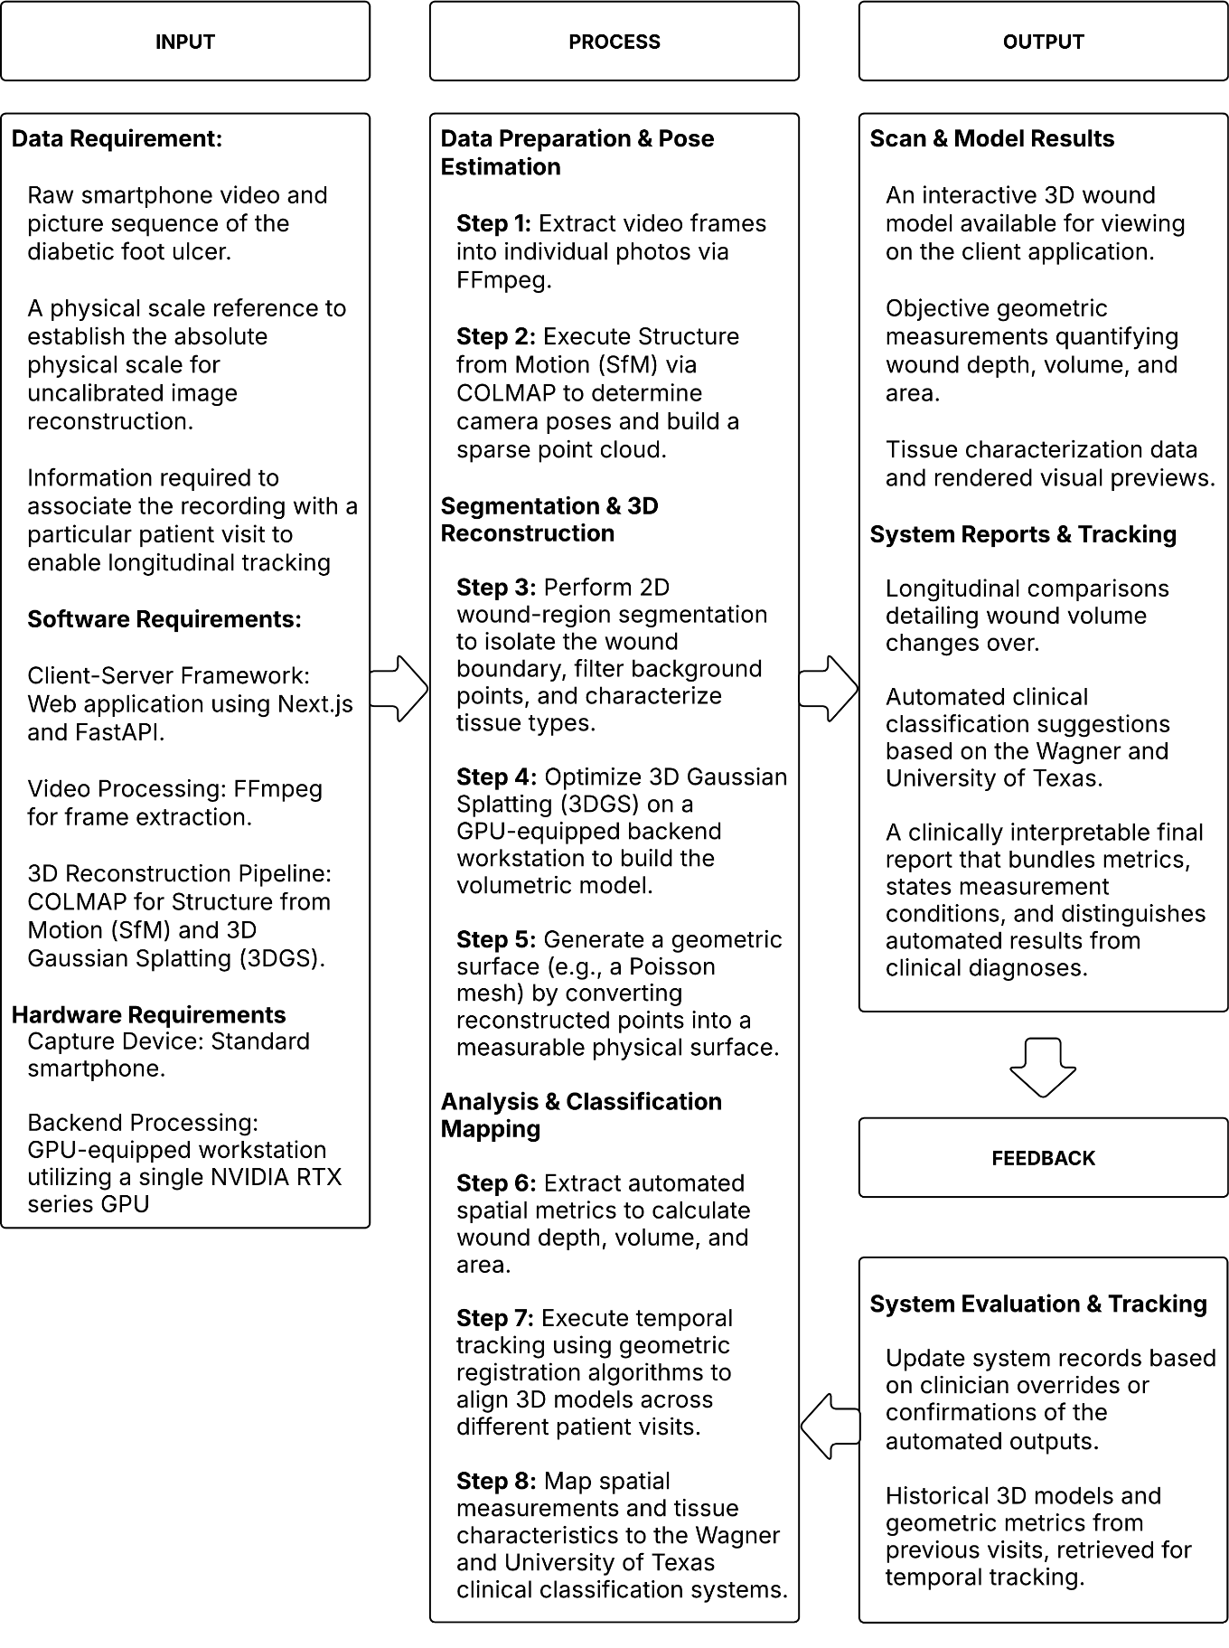

Figure 1 Wound-Splat Input–Process–Output Model
The input consists primarily of a short smartphone video of the wound and the information needed to associate the recording with a particular visit. A scale reference is important because reconstruction from uncalibrated images may recover shape without an absolute physical scale. The process begins with frame extraction and camera-pose estimation, followed by 3D reconstruction and wound-region segmentation. The reconstructed representation is filtered and converted into a measurable surface. The output consists of geometric measurements, visualizations, tissue-related information, longitudinal comparisons, and classification suggestions. The final report should state the measurement conditions and should clearly distinguish automated results from clinical diagnoses.

Research Paradigm
The revised research paradigm follows the Input–Process–Output model described above. The input is the smartphone-captured video and associated wound information. The process is the sequence of image preparation, SfM, segmentation, 3DGS optimization, surface reconstruction, geometric analysis, registration, classification mapping, and software delivery. The output is a clinically interpretable report that contains a reconstructed wound model, measurements, tissue characterization, visual previews, and change-over-time information. This arrangement directly connects the proposed system to the objectives of the study.

Flowcharts
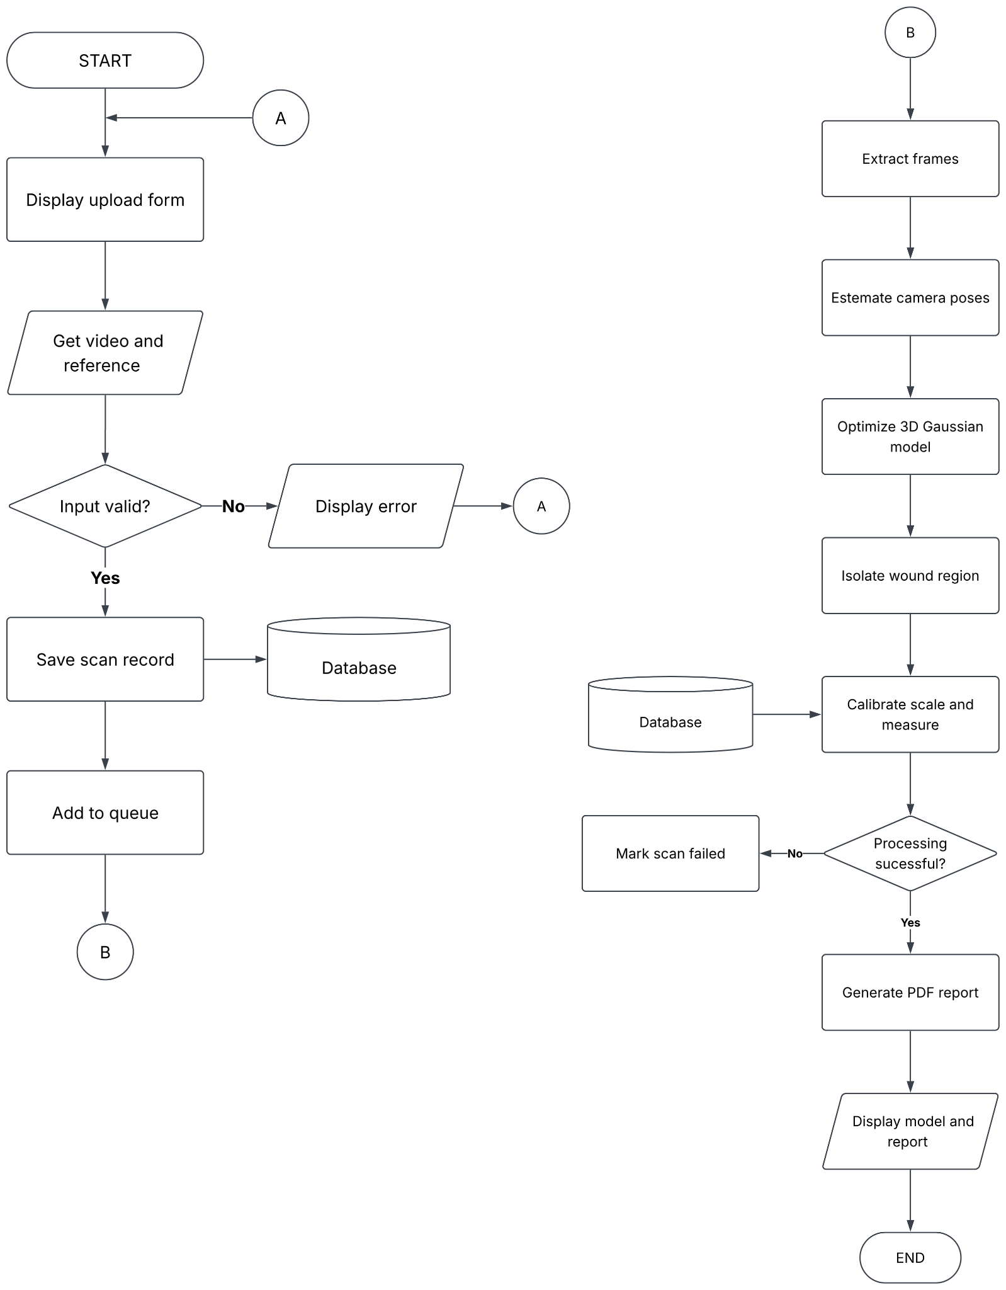

Figure 2: Wound Scan Processing and 3D Reconstruction Workflow
This figure presents the workflow of the Wound-Splat system, beginning with the upload and validation of the wound video and reference object. Once validated, the scan is queued for processing, where video frames are extracted, camera positions are estimated, and the 3D Gaussian Splatting model is optimized. The system then isolates the wound region, calibrates the measurements using the reference object, and generates a PDF report containing the wound model and measurement results.
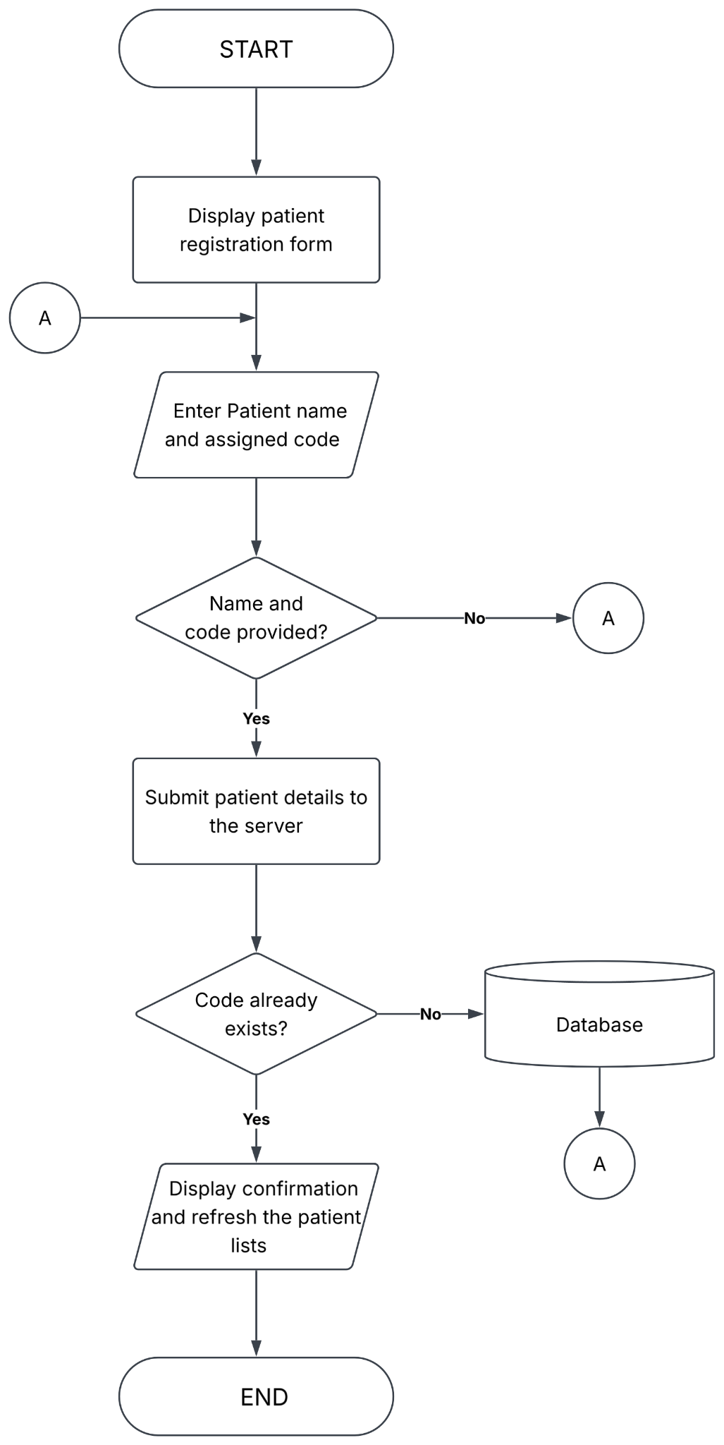

Figure 3: Patient Registration Workflow
This figure presents the patient registration workflow of the Wound-Splat system. The administrator enters the patient’s name and assigned patient code, after which the system validates the provided information and checks whether the code already exists. If the details are valid and the code is unique, a new patient record is saved in the database, a confirmation message is displayed, and the patient list is updated.
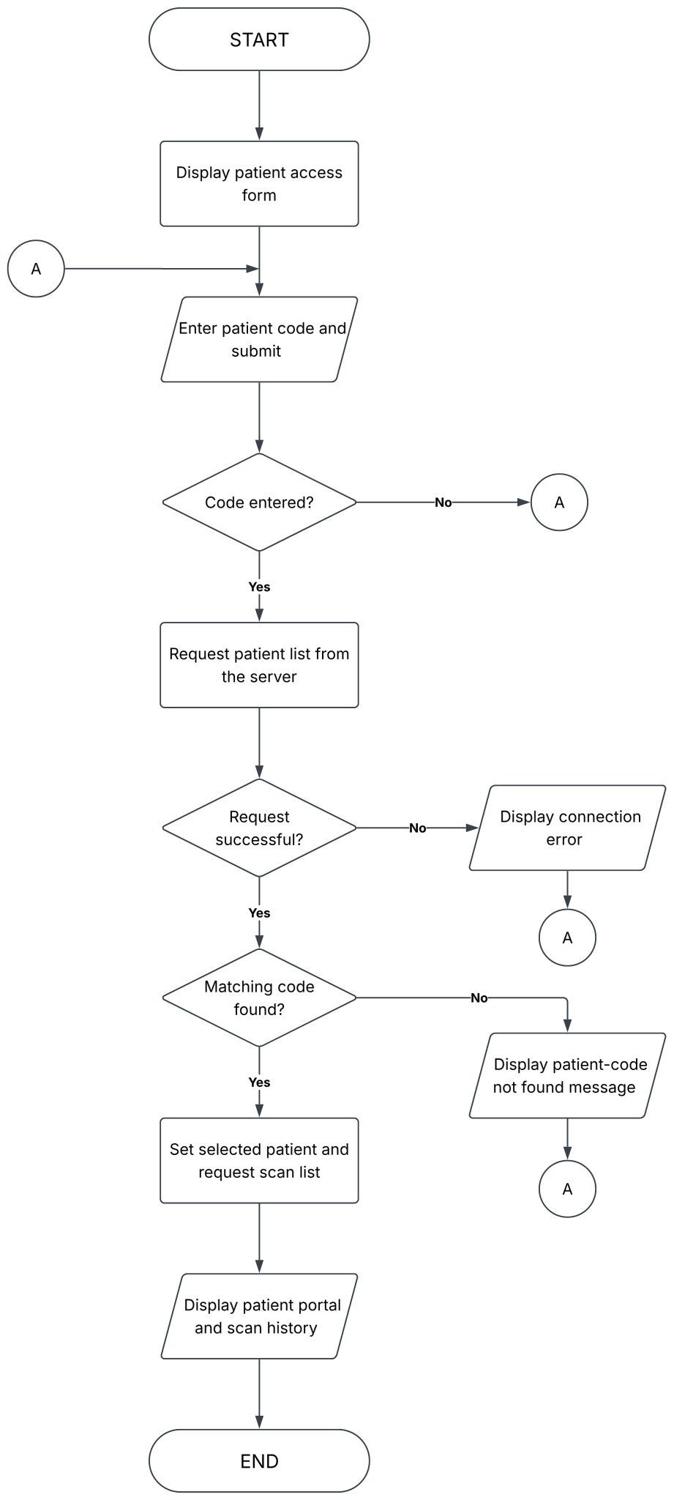

Figure 4: Patient-Code Access Workflow
This figure presents how a patient accesses their information using an assigned patient code. The system validates the entered code and searches the available patient records for a match. If the code is valid, the patient portal displays the patient’s information and available scan history. If the code is missing, invalid, or the request fails, an appropriate error message is displayed.
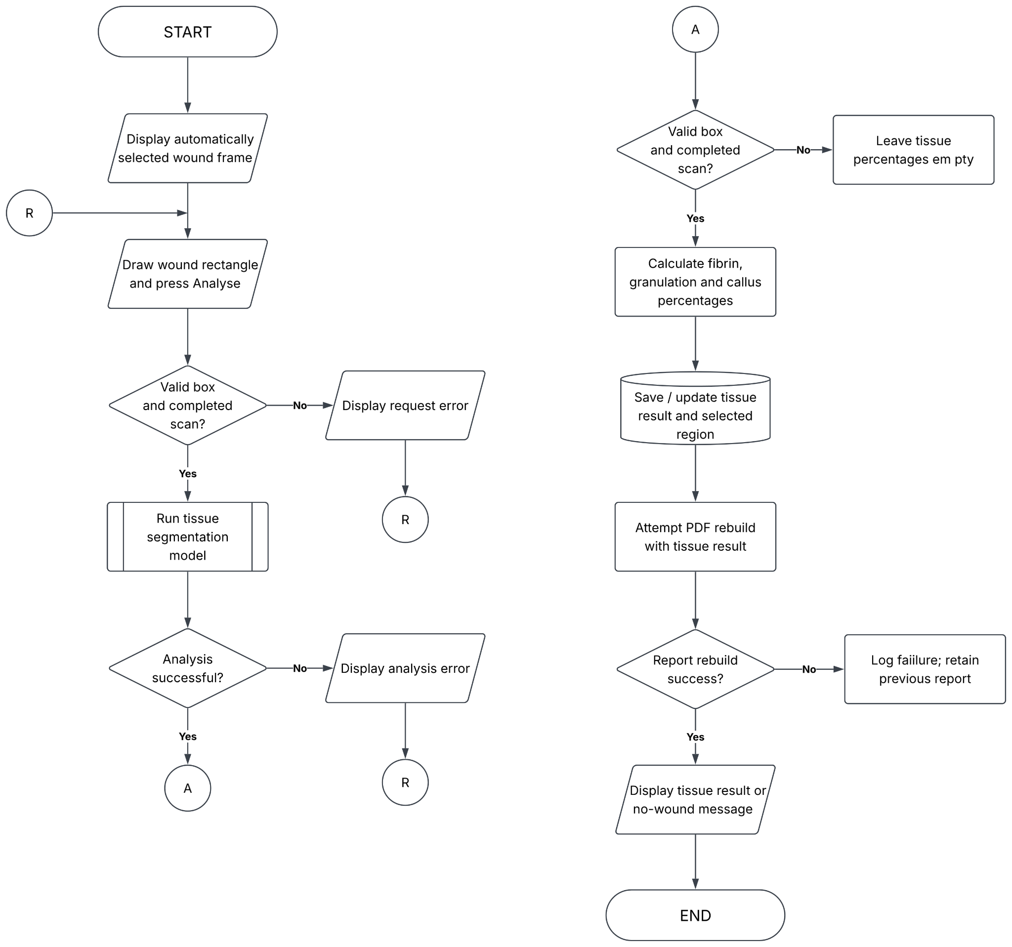

Figure 5: Wound Tissue Analysis Workflow
This figure presents the wound tissue analysis workflow after a scan has been successfully processed. The user selects a wound region from the automatically chosen frame, and the system validates the selected area before running the tissue segmentation model. The model calculates the percentages of fibrin, granulation, and callus tissue when sufficient wound pixels are detected. The results and selected region are then saved, the PDF report is updated, and the tissue analysis results are displayed to the user.

Review of Related Literature
Existing studies show that automated wound assessment is a multidisciplinary problem. A system may produce an accurate segmentation mask but still fail to provide reliable volume if the surface is curved, the camera scale is unknown, or the depth is poorly reconstructed. Conversely, a visually realistic 3D model may not be clinically useful if its wound boundary is not separated from healthy skin or if the model is not registered consistently across visits. For this reason, the review treats clinical validity, segmentation, reconstruction, geometric measurement, and usability as connected requirements rather than isolated technical tasks.

Clinical Significance of Diabetic Foot Ulcers
Diabetic foot ulceration is a serious complication of diabetes that requires repeated assessment and coordinated care. The International Diabetes Federation provides national diabetes information for the Philippines, establishing the local relevance of accessible technologies for diabetes-related complications (International Diabetes Federation, 2024). The clinical importance of monitoring is also reflected in the association between DFUs, prolonged treatment, infection, hospitalization, and lower-extremity amputation. A monitoring system should therefore be designed around the practical needs of repeated measurement and early recognition of unfavorable change rather than around visualization alone.
Wound monitoring includes more than recording whether an ulcer is present. Clinicians may need to document wound dimensions, tissue appearance, depth, exudate, periwound condition, infection indicators, ischemia, and healing trajectory. Recent systematic reviews on digital health interventions for DFUs highlight computer applications, mobile applications, optical imaging, and artificial intelligence as major technology categories, while emphasizing that imaging systems remain adjuncts to clinical care with uneven evidence for measurement accuracy across commercially available products (Kabir et al., 2024).
Three-dimensional measurements are particularly relevant because an ulcer can become smaller in area while remaining deep, undermined, or irregular. Flaherty et al. (2024) examined three-dimensional wound assessment in DFUs undergoing negative-pressure wound therapy and linked changes in wound volume with granulation-tissue velocity. This type of evidence supports the inclusion of volume and depth in Wound-Splat, while also showing that the usefulness of a measurement depends on how it relates to healing and treatment response.

Conventional Wound Measurement and Digital Monitoring
Traditional wound assessment commonly uses visual inspection, a ruler or tracing method, photographs, and narrative documentation. These methods are inexpensive and familiar, but they may be affected by observer variation, inconsistent camera position, perspective distortion, and the inability of a flat image to represent a concave wound bed. Recent reviews indicate that while some digital and handheld systems can improve measurement repeatability compared with manual approaches, many systems still lack robust evidence for accuracy and seamless integration into clinical records (Kabir et al., 2024).
Smartphone images increase portability and may support remote communication, but portability does not automatically establish diagnostic reliability. Recent evaluations of automated wound-measurement systems report strong agreement with reference planimetry overall, while also excluding cases such as multiplanar wounds and wounds with poorly defined edges (Maxant et al., 2026). This is important for the proposed system: Wound-Splat should present its results as objective measurement support and not as an autonomous replacement for physical examination, vascular assessment, infection assessment, or clinician judgment.
Mobile applications may nevertheless improve documentation when they standardize image capture, provide a scale reference, organize visits, and allow clinicians to compare measurements over time. Kabir et al. (2024) reviewed mobile applications for wound assessment and monitoring and identified opportunities for better evidence, reliability, and clinical integration. Wound-Splat responds to these concerns by defining a complete workflow from video upload to reconstruction and reporting, rather than offering an isolated camera measurement feature.

Clinical Classification Systems for Diabetic Foot Ulcers
Clinical classification gives wound measurements a language that can be communicated among healthcare professionals. The Wagner system generally emphasizes wound depth and severe outcomes such as osteitis or gangrene, while the University of Texas system combines wound grade with stages related to infection and ischemia. The two systems are relevant to Wound-Splat because the framework intends to map automated geometric and tissue-related observations to clinically recognizable categories.
Recent analyses of inter-observer agreement for the Wagner and University of Texas systems continue to find only moderate agreement among clinicians judging wound photographs, concluding that these systems should not be used as single instruments without additional clinical information (International Working Group on the Diabetic Foot, 2023). This limitation is directly relevant to system design. A rule-based mapping from depth, tissue appearance, and other measured parameters may improve consistency in documentation, but it cannot infer all variables required for complete classification, particularly infection, ischemia, perfusion, and sensory status.
The 2023 IWGDF guidelines provide a current evidence-based clinical reference for diabetes-related foot disease and include separate guidance on classification, prevention, infection, peripheral artery disease, offloading, wound-healing interventions, and practical care (International Working Group on the Diabetic Foot, 2023). These guidelines should be used to define what the proposed system can and cannot assess. In particular, RGB smartphone video can support geometric and visual measurements but cannot independently measure blood flow, skin temperature, or all clinical signs needed for a complete DFU assessment.

Smartphone-Based Photogrammetry and Volumetric Analysis
Smartphone-based photogrammetry uses overlapping images or video frames to estimate the geometry of an object. The approach is appealing for wound monitoring because smartphones are widely available and can record a wound without direct contact. De Waele et al. (2026) described an automated smartphone-video pipeline for residual-limb reconstruction that combined background removal, ArUco-based scaling, open-source SfM, and dense MVS. Their work demonstrates the feasibility of using consumer-grade capture for medical modeling, while also illustrating the computational cost of dense reconstruction.
Wound-specific benchmark studies make the comparison more meaningful than evidence from general 3D scenes alone. Chierchia et al. (2025a) introduced SALVE, a benchmark based on videos of realistic wound phantoms captured with consumer-grade cameras. The authors compared traditional photogrammetry and neural-rendering approaches and reported that conventional photogrammetry may not produce smooth surfaces suitable for precise clinical wound measurement. This result supports the need for an explicit surface-quality evaluation in Wound-Splat rather than evaluating only the visual appearance of a rendered model.
Lebrat et al. (2024) introduced Syn3DWound, a synthetic dataset for three-dimensional wound-bed analysis with two-dimensional and three-dimensional annotations. Such datasets are valuable when real patient data are limited by privacy, consent, and annotation costs. They also allow researchers to compare the reconstructed geometry with known ground truth. Wound-Splat follows the same general principle by beginning with simulated wound models for baseline validation, while recognizing that phantom accuracy does not by itself establish clinical validity.
Wound3DAssist provides a particularly close comparison to the proposed system. Chierchia et al. (2025b) presented a framework using short monocular consumer-grade videos and integrated 3D reconstruction, wound segmentation, tissue classification, and periwound analysis. The record reports evaluation on digital models, silicone phantoms, and real patients, with millimeter-level accuracy and assessment times below twenty minutes. Wound-Splat differs in its intended emphasis on a 3DGS-centered pipeline, GPU-backend deployment, longitudinal registration, and mapping to the Wagner and University of Texas systems.

Structure from Motion, Multi-View Stereo, and COLMAP
Structure from Motion estimates camera poses and sparse scene geometry from multiple images. The method depends on feature detection, feature matching, geometric verification, triangulation, and bundle adjustment. Recent implementations of incremental SfM systems, such as those utilized in modern open-source pipelines like COLMAP, continue to prioritize robustness, accuracy, completeness, and scalability in complex environments (Liu et al., 2024). This source is important for Wound-Splat because COLMAP is used to estimate camera poses and generate a sparse point cloud before densification or Gaussian optimization.
MVS extends the sparse reconstruction by estimating depth over many views and producing a denser representation. In wound imaging, MVS can be challenged by textureless skin, specular moisture, shallow cavities, occlusion, and limited camera motion. De Waele et al. (2026) illustrate the practical trade-off: dense MVS can yield accurate models but may require long processing times. Wound-Splat therefore treats SfM as a necessary geometric foundation while exploring 3DGS.
The quality of the input video remains a major determinant of reconstruction quality. The capture procedure should provide sufficient overlap between frames, stable motion, consistent lighting, visible wound boundaries, and an identifiable scale reference. The system should also reject or flag videos with excessive blur, low texture, motion discontinuity, or incomplete coverage. These requirements should be described in the methodology because a reconstruction algorithm cannot compensate for missing viewpoints or inadequate scale information in every case.

Neural Radiance Fields and 3D Gaussian Splatting
Neural Radiance Fields represent a scene through a learned function that maps spatial coordinates and viewing direction to density and color. NeRF-based methods can produce high-quality novel views, but rendering commonly requires sampling along camera rays, which may increase computational cost. The limitations of implicit neural representations motivated research into explicit or semi-explicit representations that can be optimized and rendered more efficiently.
Kerbl et al. (2023) introduced 3D Gaussian Splatting as an explicit representation for real-time radiance-field rendering. A scene is modeled using anisotropic Gaussian primitives whose positions, covariances, opacity, and appearance are optimized from calibrated views. A tile-based rasterizer then projects and blends these primitives efficiently. For Wound-Splat, the principal advantage is the possibility of fast interactive visualization and shorter reconstruction time compared with computationally intensive neural rendering or dense MVS.
The principal limitation is that 3DGS is optimized primarily for image reconstruction and rendering quality rather than for a clean, watertight physical surface. Floaters, disconnected primitives, inconsistent depth, and irregular boundaries may produce visually plausible results while corrupting wound-volume calculations. Therefore, a 3DGS model should not be treated as the final measurement surface without geometric post-processing and quantitative validation.
Several recent studies extend 3DGS to medical or deformable scenes. Yang et al. (2024) proposed Deform3DGS for flexible surgical-scene reconstruction, while Xie et al. (2024) developed SurgicalGaussian for high-fidelity modeling of deformable surgical environments. Zheng et al. (2025) proposed SurGSplat, which progressively adds geometric constraints to improve the consistency of surgical reconstruction. Although these studies do not focus on DFUs, they demonstrate that Gaussian-based representations can be adapted to biological surfaces and that medical applications require more than unconstrained visual optimization.
Efficiency research also informs the Wound-Splat architecture. Liao et al. (2025) proposed LiteGS to reduce 3DGS training time through system and algorithm co-design. Clini et al. (2024) compared NeRF, Gaussian Splatting, and SfM-MVS using low-cost sensors and reported substantial processing-time differences among the methods. These studies support the use of a GPU-backed service, but their results should not be transferred directly to clinical wound accuracy without wound-specific testing.

Surface Reconstruction and Geometric Wound Measurement
A wound-volume calculation requires a surface or volume representation with a meaningful boundary. A point cloud or collection of Gaussian primitives may be sufficient for visualization but is not automatically a closed surface. Wound-Splat therefore separates these two requirements. A surface-reconstruction stage converts the segmented points into a triangle mesh using Poisson surface reconstruction, which provides the smooth, closed surface used for visualization and for exporting the wound model. Geometric measurement, however, is performed directly on the segmented point cloud rather than on the mesh, so that the reported values do not inherit the smoothing and hole-filling behavior that Poisson reconstruction applies to concave regions.
Recent comparative studies on surface reconstruction for medical point clouds emphasize that Poisson reconstruction remains a viable method for generating watertight surfaces from oriented points, particularly when resilience to noise is required (Molnár-Zékány & Homolya, 2026). This property is relevant to wound imaging because the reconstructed point cloud may contain small gaps, outliers, and uneven sampling. However, Poisson reconstruction depends on reliable point normals and may smooth or close features that are clinically meaningful. The method must therefore be evaluated on wound phantoms with known geometry.
Molnár-Zékány and Homolya (2026) compared Poisson reconstruction and the Ball-Pivoting Algorithm for wound point clouds and emphasized that no single method is optimal for every wound shape. Poisson reconstruction is attractive when a watertight surface is required, whereas local methods may preserve fine features. B. Huang et al. (2025) proposed a hybrid mesh-Gaussian representation in another reconstruction context, suggesting that relatively flat periwound skin and a geometrically complex wound cavity may be represented differently. Wound-Splat adopts Poisson reconstruction for its watertight output, since the mesh is used for visualization rather than measurement. Comparison with local methods such as Ball-Pivoting remains open work.
Geometric measurements must be tied to a defined reference surface. Wound area may refer to the opening projected onto a plane or to the actual curved surface area. Maximum depth requires a reference plane or reference region representing the surrounding skin. Volume requires a closed boundary and a defined base.

Deep Learning for Wound Segmentation and Tissue Characterization
Segmentation is the bridge between a raw image and a clinically meaningful measurement. The wound boundary must be separated from healthy skin, footwear, dressings, background, and other objects before reconstruction points can be restricted to the region of interest. Segmentation serves two distinct purposes in Wound-Splat, and the framework addresses them with separate mechanisms. The first is spatial: the wound region must be separated from healthy skin, background, and other objects before measurement. The second is descriptive: the tissue inside that region must be characterized by type. The two operate at different stages and on different data, so they are described separately below.
Encoder–decoder networks, heavily popularized by foundational architectures like U-Net and extensively reviewed in recent biomedical segmentation literature (Z. Huang et al., 2025), remain highly effective when annotated medical images are limited. Wound-splat may use encoder-decoder networks, popularized by U-Net and reviewed in recent biomedical segmentation literature (Huang et al., 2025b), and remain effective when annotated medical images are limited. General-purpose models such as HarDNet-MSEG, SAM, and SAM 2 were considered but not adopted, because tissue characterization requires a model trained on labeled wound tissue rather than one assumed to generalize from unrelated biomedical images.
Chen et al. (2023) investigated a diabetic-foot-ulcer segmentation strategy that combines HarDNet-MSEG and Segment Anything Model components. The study demonstrates the value of combining a task-specific segmentation architecture with a general segmentation foundation model. For Wound-Splat, the segmentation output creates a clinically interpretable wound mask and tissue map, and restricts the reconstructed point cloud to the wound region before measurement.
Wound isolation. Wound-Splat isolates the wound after reconstruction rather than before it. Wound tissue is strongly saturated and red, while dressings, reference markers, and background are not, so points in the reconstructed cloud are gated by hue and saturation and the largest connected cluster is retained. A margin of surrounding skin is deliberately preserved, because the measurement stage fits its reference plane to that periwound region. The method is fast and requires no training data, but it depends on color and is therefore sensitive to lighting, exudate, and camera color response.
Tissue characterization. Tissue type is determined by a supervised segmentation network applied to a selected video frame rather than to the 3D model. The network uses a Mix Transformer encoder with an attention-gated convolutional decoder, following DFUTissueSegNet (Dhar et al., 2024), and is trained on the DFUTissue dataset under permission granted for nonprofit academic use. It labels fibrin, granulation, and callus, reporting each as a percentage of the identified wound area.
Two limitations follow from this design. The dataset defines only three tissue classes, so necrotic tissue, eschar, and slough have no corresponding label and would be assigned one of the three available categories. The model also has no "not a wound" class, so the region submitted for analysis must be selected to contain a wound; the system reports when no wound tissue is found rather than forcing a label.
Recent work combining wound segmentation with 3D reconstruction for the generation of three-dimensional bio-printable patches for DFU treatment highlights the growing intersection of segmentation and generative tasks (Chae et al., 2022). Their work directly supports segmentation-guided reconstruction and illustrates how two-dimensional semantic information can improve a three-dimensional wound representation. Kryvoshei et al. (2026) similarly used neural segmentation to guide Gaussian-based reconstruction of cerebral angiography. These studies provide transferable methods, but the transfer must be tested because a wound bed has different texture, depth, lighting, and boundary characteristics from vessels or surgical scenes.
Chierchia et al. (2026) evaluated WoundNeRF in the paper titled “Multi-View Consistent Wound Segmentation With Neural Fields”. The work addresses the problem of keeping segmentation consistent across multiple views and compares the method with Vision Transformer and rasterization-based approaches. It is relevant to Wound-Splat because frame-by-frame masks may vary even when the underlying wound is unchanged. A temporally or geometrically consistent segmentation strategy could reduce measurement noise across frames and visits.

Datasets, Benchmarks, and Validation
Public datasets make it possible to compare segmentation models using common images and evaluation measures. The DFUC2022 dataset was created from clinician-delineated diabetic-foot-ulcer images and was accompanied by benchmark experiments on machine-interpretable wound boundaries. Recent challenges, including DFUC 2023 and DFUC 2024, continue to provide standardized benchmarks for algorithm comparison, with recent studies utilizing the DFUC 2024 dataset to develop temporal machine learning frameworks for predicting wound healing trajectories (Basiri et al., 2026).
The tissue-characterization model is trained on the DFUTissue dataset, used with written permission from its custodian at the University of Wisconsin–Milwaukee. The terms restrict use to nonprofit academic research, prohibit redistribution of the data, and require citation of the associated publications (Dhar et al., 2024). The dataset is therefore not distributed with the software.
Synthetic and phantom data are especially useful for three-dimensional validation because the ground-truth dimensions can be measured directly. SALVE and Syn3DWound provide wound-oriented benchmark resources, while Wound3DAssist demonstrates evaluation using digital models, silicone phantoms, and real patients. Wound-Splat’s phantom-based validation is appropriate for an initial software study, but the limitations must be explicit: phantom results cannot establish performance across wound etiologies, skin tones, lighting conditions, wound exudate, patient movement, or clinical stages.
Evaluation should include both reconstruction accuracy and application performance. Reconstruction metrics may include absolute or relative error for volume, depth, area, and surface distance, together with completeness and failure rate. Segmentation may be evaluated using Dice similarity, intersection over union, precision, recall, and boundary distance. Application performance may include processing time, upload success, reliability, security, usability, and the clarity of the generated report. Using several metrics is preferable to reporting a single accuracy value because the system can be visually convincing while still producing clinically important geometric errors.

Longitudinal Monitoring and Three-Dimensional Registration
Monitoring healing requires comparison across visits, not merely measurement at one time. A later wound model must be aligned with an earlier model before changes in volume, depth, or surface shape can be attributed to healing rather than to camera position or scale differences. Registration may use fiducial markers, stable anatomical features, a shared capture protocol, or a combination of these methods.
ICP iteratively establishes point correspondences and estimates the transformation that minimizes a distance objective. It is a useful baseline for Wound-Splat’s temporal tracking module, but it is sensitive to initialization, outliers, missing data, and changes in the wound itself. Registration should therefore be restricted or weighted toward stable periwound regions, and the system should report when alignment quality is insufficient.
Longitudinal measurements should also be interpreted with uncertainty. Small changes may result from lighting, camera distance, video coverage, segmentation variation, or mesh reconstruction noise rather than biological healing. The application should preserve the capture date, scale information, processing settings, and quality indicators so that clinicians can judge whether a change is meaningful. This requirement links the geometric-registration literature to the clinical need for reliable trend interpretation.

GPU Acceleration and Client–Server Architecture
The processing stages of Wound-Splat are suitable for parallel execution. Image decoding and frame extraction can be pipelined, feature matching can be parallelized across image pairs, and 3DGS rasterization and optimization can use GPU threads. The separation of the web interface from the reconstruction backend also allows the system to accept uploads from standard devices while reserving specialized hardware for the most demanding stages.
The architecture introduces operational requirements that are not present in an offline experiment. Uploaded videos may contain identifiable health information, so access control, secure transmission, storage limits, and deletion policies should be considered. The system should handle interrupted uploads, failed reconstruction, invalid video formats, and GPU memory limits. A clinically useful application should communicate processing status and failure reasons rather than silently returning an incomplete model.

Software Product Quality, Usability, and Clinical Interpretability
A wound-assessment application is not evaluated only by its algorithmic accuracy. Users must be able to upload the intended video, understand the result, and repeat the procedure consistently. The ISO/IEC 25010:2023 product-quality model provides a structured vocabulary for evaluating software quality, including functional suitability, performance efficiency, compatibility, usability, reliability, security, maintainability, and portability (International Organization for Standardization, 2023). The Wound-Splat study selects functional suitability, performance efficiency, reliability, security, and usability as evaluation dimensions, which should be defined with observable indicators and user-rating criteria.
Usability is particularly important for smartphone-based monitoring because inconsistent capture instructions can reduce reconstruction quality. The interface should communicate how to move the camera, maintain distance, include the entire wound, use a scale reference, and avoid glare or occlusion. Clinical interpretability is equally important: the report should define each metric, show the relevant preview, indicate the measurement unit, and identify whether a classification is an automated suggestion or a clinician-confirmed assessment. The adoption of the ISO/IEC 25010:2023 standard ensures that the evaluation terminology remains current and internally consistent, replacing previous withdrawn editions.

Synthesis and Research Gap
The clinical literature establishes the need for repeated, objective, and interpretable wound monitoring. Traditional measurements and two-dimensional photographs remain useful, but they may not represent wound depth, curved-surface area, or volume accurately. Mobile images can support communication and documentation, yet peer-reviewed evidence also warns that they should not be used as stand-alone diagnostic instruments. Clinical classification systems support communication but show only moderate agreement when used from photographs and do not capture every factor required for complete DFU management.
The technical literature shows that smartphones can serve as practical data sources for 3D reconstruction when capture quality, scale, and viewpoint coverage are controlled. SfM and COLMAP provide camera poses and sparse geometry, while MVS can produce dense models at a substantial computational cost. NeRF and 3DGS offer alternative representations, with 3DGS providing attractive rendering speed but requiring additional geometric processing before it can support clinical measurement. Poisson reconstruction, geometry regularization, hybrid representations, and segmentation-guided initialization are possible strategies for improving the measurement surface.
The literature also shows that segmentation and reconstruction should not be developed as independent modules. A wound mask can remove irrelevant background points, improve the allocation of Gaussian primitives, and provide the boundary required for measurement. Conversely, a multi-view or three-dimensional reconstruction can improve the consistency of segmentation across frames. Datasets such as DFUC2022, Syn3DWound, and SALVE provide useful benchmarks, but phantom-based validation and public-image segmentation do not fully reproduce the conditions of longitudinal clinical monitoring.
The central research gap is therefore not the absence of smartphone wound imaging or the absence of 3D reconstruction in isolation. More specifically, there remains a need for an integrated and explicitly evaluated workflow that combines smartphone video input, SfM-based camera estimation, wound-region segmentation, fast 3DGS reconstruction, geometric surface generation, volumetric measurement, registration across visits, and clinically interpretable reporting. Wound3DAssist demonstrates that integrated 3D wound assessment is feasible, so the contribution of Wound-Splat should be framed as an investigation of a 3DGS-centered, GPU-backed, longitudinal DFU monitoring workflow and its performance under the study’s defined phantom and software-quality evaluation conditions.
Wound-Splat addresses this gap by integrating these stages in a client-server application and by mapping measurable outputs to the Wagner and University of Texas systems while acknowledging their clinical limitations. Its contribution lies in the system-level integration, the use of smartphone video and 3DGS for accessible reconstruction, the use of segmentation to isolate the wound region, the conversion of reconstructed points into a measurable surface, and the comparison of wound models across visits. The framework should not be presented as a substitute for clinical diagnosis; rather, it is a technical decision-support system whose accuracy, reliability, usability, security, and limitations must be documented through transparent validation.

Definition of Terms
The following are unique terminologies used in the study to help readers understand this research:

3D Gaussian Splatting (3DGS) | A GPU-accelerated reconstruction technique using explicit geometry and CUDA for real-time model rendering.
Diabetic Foot Ulcer (DFU) | A severe diabetes complication requiring continuous monitoring of tissue appearance and wound volume.
Structure from Motion (SfM) | A computer vision method estimating camera poses and generating 3D point clouds from overlapping frames.
Wound Segmentation | The automated isolation of wound boundaries from healthy skin and classification of interior tissue types.
Longitudinal Monitoring | Tracking physical wound changes over time by aligning 3D models across multiple patient visits.
Neural Radiance Fields (NeRF) | An implicit neural rendering approach that is generally more computationally heavy than explicit 3DGS.
Poisson Surface Reconstruction | A geometric method that converts a reconstructed point cloud into a smooth, watertight 3D mesh.
Wagner and University of Texas Systems | Established clinical diagnostic standards used to map automated spatial metrics into interpretable clinical outputs.
Client-Server Architecture | A design separating frontend video uploads from computationally intensive backend GPU 3D reconstruction.
CUDA | A parallel computing platform used to rapidly optimize and rasterize 3D Gaussians.
Photogrammetry | Deriving 3D measurements from overlapping 2D photographs, noted as computationally heavy compared to 3DGS.
Scale Calibration | Deriving absolute physical measurement scales by computationally detecting a known reference object during capture.
Temporal Tracking | A module utilizing geometric registration to align 3D models and automate volume change calculations.

CHAPTER 3 Methodology
This chapter introduces the methodology for the proposed Wound-Splat framework, explaining the software and hardware integration needed for the development and implementation of the framework. It offers a detailed description of the client-server infrastructure, 3D reconstruction and segmentation algorithms, and evaluation procedures that support the development and deployment of the system for diabetic foot ulcer monitoring.

Project Materials
This section identifies the software, hardware, and data used to develop and evaluate the Wound-Splat framework. The system integrates existing research components for video processing, three-dimensional reconstruction, geometric measurement, tissue characterization, visualization, and report generation. The contribution of the study lies in adapting and integrating these components into a unified wound-assessment support workflow. Reproduction of the development environment requires the recorded dependency versions, operating-system tools, CUDA configuration, model weights, and experimental settings.

Software
Component | Version | Function in the framework
Python | 3.11.x | Backend, reconstruction, measurement, and tissue-model execution
Node.js | 18 or later; Node.js 20 recommended | Frontend development and execution
CUDA toolkit | 12.6 | GPU acceleration and compilation of CUDA extensions
NVIDIA display driver | 610.62 | Device driver for supporting CUDA 12.6
Visual Studio 2022 Build Tools | 2022 with C++ workload | Compilation of Gaussian-splatting extensions on Windows
COLMAP | 3.x or 4.x | Camera-pose estimation and sparse reconstruction
FFmpeg | Installed development version | Video-frame extraction
Git and GitHub | Installed development version | Source-code and version management

Table 1: System-Level Toolchain
Table 1 presents the system-level tools used in the development and operation of Wound-Splat. Python 3.11 and CUDA Toolkit 12.6 form part of the tested development configuration. The Gaussian-splatting extensions require compatible versions of Python, PyTorch, the CUDA toolchain, and the C++ compiler. COLMAP performs camera-pose estimation and sparse reconstruction, while FFmpeg extracts video frames for processing. The listed versions describe the environment used in this study and do not establish that all other versions are unsupported.
Package | Version | Function in the framework
FastAPI | 0.136.3 | Web API framework serving the client application
Uvicorn | 0.49.0 | Application server hosting the API
SQLAlchemy | 2.0.50 | Object-relational mapping over the SQLite database
Pydantic | 2.13.4 | Validation of request and response data
python-multipart | 0.0.32 | Handling of video file uploads
PyTorch | 2.12.0+cu126 | Tensor computation and GPU acceleration
TorchVision | 0.27+cu126 | Image transformation utilities
NumPy | 2.4.6 | Numerical array operations
SciPy | 1.17.1 | Spatial and statistical routines used during measurement
OpenCV | 4.13.0.92 | Image processing and reference-object detection
Open3D | 0.19.0 | Point cloud processing, plane fitting, and surface reconstruction
plyfile | 1.1.4 | Reading and writing of point cloud files
Pillow | 12.2.0 | Image file input and output
ReportLab | 4.5.1 | Generation of the PDF assessment report
diff-gaussian-rasterization | Built from source | CUDA rasterizer for 3D Gaussian Splatting
simple-knn | Built from source | CUDA nearest-neighbor routine used during 3DGS optimization

Table 2: Backend Dependencies
Table 2 presents the principal backend dependencies of Wound-Splat. The FastAPI application handles system requests, stores scan information, and invokes the reconstruction and measurement pipeline. PyTorch and the locally compiled diff-gaussian-rasterization and simple-knn extensions support 3D Gaussian Splatting. Open3D, OpenCV, NumPy, and SciPy support point-cloud processing, image processing, and geometric calculations. The active application uses an in-process background worker that handles reconstruction jobs sequentially. Although Celery and Redis remain available as optional dependencies, they are not used by the current execution path.
Package | Version | Function in the framework
Next.js | 16.2.9 | Web application framework and development server
React | 19.2.4 | User interface component library
Three.js | 0.184.x | WebGL rendering layer for the browser viewer
@mkkellog/gaussian-splats-3d | 0.4.x | In-browser renderer for 3D Gaussian Splatting models
Tailwind CSS | 4.x | Styling framework
TypeScript | 5.x | Statically typed language used for application code

Table 3: Frontend Dependencies
Table 3 presents the principal dependencies of the Wound-Splat web client. The application provides the patient portal, clinical administration view, upload interface, processing-status display, tissue-analysis interface, and interactive reconstruction viewer. The viewer supports point-cloud display, optional Poisson-mesh visualization, and an optional Gaussian-splat rendering mode. These representations allow reconstructed scans to be inspected through a web browser, but they do not determine how the wound measurements are calculated.
Package | Version | Function in the framework
segmentation-models-pytoch | 0.5.0 | Provides the Mix Transformer encoder and attention-gated decoder
timm | 1.0.29 | Pre-trained image model weights used to initialize the encoder
PyTorch | 2.12.0+cu126 | Training computation
pytest | 0.1.1 | Automated test execution
TorchVision | 0.27.0+cu126 | Image transformations
Numpy | 2.4.6 | Numerical processing
Pillow | 12.2.0 | Image loading and preprocessing
pypdf | 6.18.0 | Verification od generated tissue report content

Table 4: Tissue-Model Training Environment
The tissue-characterization component is maintained in a separate Python environment from the reconstruction backend to protect the compiled CUDA dependencies of the 3D Gaussian Splatting pipeline. Its segmentation model uses a U-Net architecture with a MiT-b3 encoder and scSE attention. The model processes an operator-selected region of a two-dimensional video frame and estimates the proportions of fibrin, granulation, and callus tissue. This tissue analysis is separate from the three-dimensional point-cloud isolation and geometric measurement process.

Hardware
Two computing platforms were used, differing in the amount of graphics memory available. Their specifications are given in Table 5.
All application code, the user interface, and the tissue-characterization model were developed and trained on a consumer laptop. Its 6GB VRAM suffices for training the tissue model and for reconstruction scans of moderate length, and remaining within that limit is what allows the framework to be called deployable on ordinary hardware.
A rented cloud processor handles runs that exceed that limit. 3DGS optimization holds every Gaussian primitive in the video memory, and this requirement grows with the number of frames and the density of the scene. The rented instance is providing 48GB, runs the full stack under the headless Linux operating system, and is billed hourly, so it is provisioned only when needed.
Specification | Development machine | Cloud processing instance
Role | Development, tissue-model training, standard reconstruction | High-memory reconstruction runs
Processor | Intel Core i5-14500HX (14 cores, 20 threads) | Virtualized host processor
System memory | 32 GB | 50GB
Graphics processor | NVIDIA GeForce RTX 4050 Laptop GPU | NVIDIA A40
Video memory | 6 GB | 48 GB
Operating System | Windows 11 | Ubuntu Linux (headless)
Provisioning | Owned | Rented on demand (approx. USD 0.45 per hour running, USD 0.01 on idle)

Table 5: Computing Hardware
An NVIDIA graphics processor is required on either platform. The Gaussian Splatting rasterizer is implemented as a CUDA extension, and it has no processor-only fallback; the framework will not execute on the system without compatible NVIDIA hardware.

Dataset
Training the tissue-characterization component will require wound images in which each pixel has been labelled with its tissue type by a qualified annotator. Producing such annotations requires clinical expertise that is not available to this study yet, so an annotated dataset was obtained rather than created.
The DFUTissue dataset (Dhar et al., 2024) was used. It consists of diabetic foot ulcer photographs with pixel-level tissue annotations, that is distributed by the Big Data Analytics and Visualization Laboratory of the University of Wisconsin-Milwaukee. Its composition is summarized in Table 6.

Property | Description
Annotated images | 110, divided by authors into 78 training, 16 validation, and 16 test images
Unannotated images | 600 (currently not used in this study)
Tissue classes | Fibrin, granulation, and callus, in addition to background
Annotation format | Color-coded masks: red denotes fibrin, green for granulation, and blue for callus.
Image dimensions | Variable, ranging from 67x67 to 266x266 pixels
Preprocessing applied in this study | Images resized to 256 × 256 using bilinear interpolation; class-index masks resized using nearest-neighbor interpolation.

Table 6: Composition of DFUTissue Dataset
Two properties of the dataset shape the methodology. First, it is small, with around 78 annotated images for training, which is a constraint for both the choice of model and the evaluation of the procedure used later in this chapter. Second, the images are zero-padded, with genuine content occupying only 53 to 85 percent of each frame. Padding is removed before any accuracy measurement because uniform padding is trivially classified as background and inflates the measured score.
The class-to-color correspondence in Table 6 is taken from the palette file distributed with the dataset, not inferred from the masks. The 600 unannotated images are not used; the rationale is presented under Algorithm Implementation.
Permission and terms of use are available. DFUTisse is not openly licensed. Written permission was granted by Prof. Zeyun Yu of the University of Wisconsin-Milwaukee on September 4, 2026, restricting use to nonprofit academic research, prohibiting redistribution, and requiring citation. The dataset is therefore excluded from the project's public repository and not distributed anywhere within the software; the permission correspondence is retained as a record of compliance.
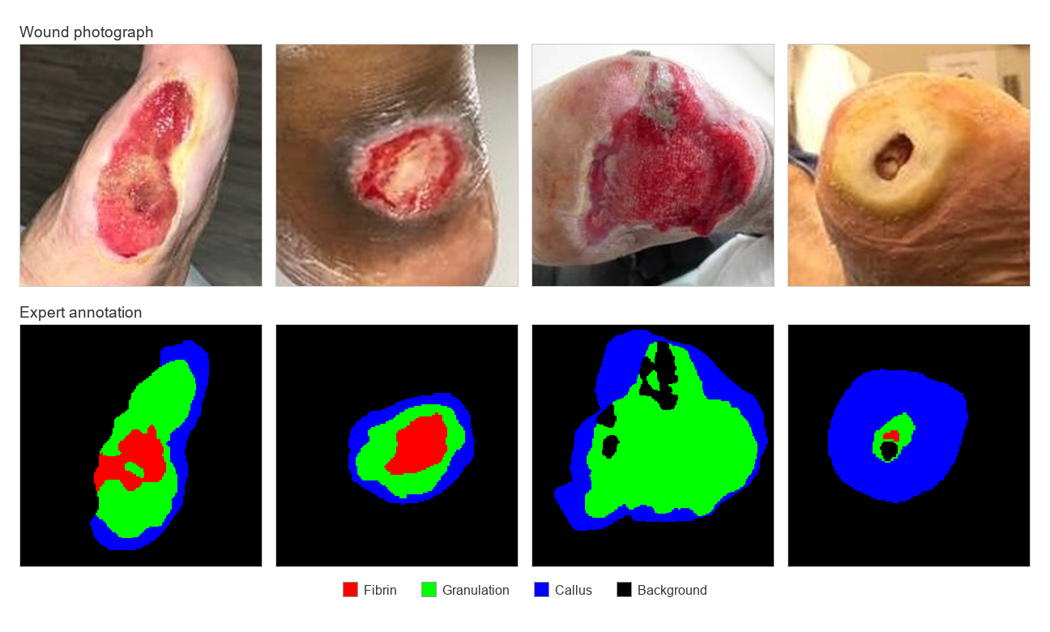

Figure 6: DFUTissue sample

Data Sources
Source | Quantity | Purpose | Ground truth available
DFUTissue labeled images | 110 | Tissue-model training and quantitative evaluation | Expert pixel-level annotations
DFUTissue unlabeled images | 600 | Not used | Excluded because semi-supervised training was not implemented
Self-captured smartphone videos | Count to be confirmed | Reconstruction and workflow development | No complete physical end-to-end accuracy record
Clay wound-like model | Saved recordings available | Workflow and cavity-processing demonstration | Clay has no valid tissue labels; the physical model no longer exists
Synthetic point-cloud phantoms | Three primary shapes plus calibration checks | Testing the geometric measurement routine | Analytic geometric targets; bypasses video reconstruction
Additional wound photographs | Source and permission must be documented | Qualitative tissue-model inspection only | No expert masks; cannot produce an accuracy score

Table 7: Data Sources and Purpose
No prospective patient wound videos were collected, and no clinical validation of the complete Wound-Splat application is reported in this study. The wound images used for tissue-model development were obtained from secondary data sources under their documented conditions of use. Self-captured reconstruction videos used non-patient objects and wound-like models. However, interviews and software-evaluation questionnaires involve human respondents and must be documented separately, including respondent selection, consent, privacy measures, and the institution’s determination of the applicable review requirements.

Data collection
Self-captured video recordings were made using a smartphone under controlled indoor lighting conditions specified in the delimitations; each recording follows the capture protocol the framework requires. The subject is filmed continuously from multiple angles or viewpoints, beginning directly above and proceeding around the subject at a moderate and steady pace, ensuring substantial visual overlap between consecutive frames. Structure-from-motion requires this overlap to match features across frames and recover camera positions accurately.
The reference object of known physical size, like a standard bank card or a coin, is placed flat beside the subject and remains visible in the frames. Reconstruction from uncalibrated images recovers the shape of a scene but not its absolute size, and this reference object is what allows reconstructed dimensions to be converted into centimeters.
Self-captured recordings of rigid objects and a clay wound-like model were used during reconstruction development and workflow demonstrations. The concave clay model allowed the reconstruction and measurement stages to be exercised on a cavity resembling wound geometry. However, a successful reconstruction does not constitute an accuracy test unless independent physical measurements and comparison results are retained. The present project record does not establish end-to-end physical measurement accuracy. The saved clay videos, frames, and reconstructions remain available, but the physical clay model is no longer available for new ground-truth measurements.
Synthetic point-cloud phantoms provide known geometric targets for testing the wound-measurement routine. The validation suite generates a spherical cap, a half-ellipsoid, and a shallow crater with analytically defined opening area, cavity volume, maximum depth, width, and height. Rotation and noise are introduced before the generated point clouds are passed to the measurement algorithm. These tests assess the geometric calculations but bypass smartphone capture, frame extraction, COLMAP camera-pose estimation, 3D Gaussian Splatting, wound-region isolation, and automatic reference-object detection. The resulting errors therefore represent measurement-algorithm performance on synthetic point clouds rather than end-to-end reconstruction accuracy.
Publicly available wound photographs: Fourteen of the photographs of diabetic foot ulcers were collected from publicly accessible online sources, including stock photography services, published article figures, and general image searches; none originate from DFUTissue. They were used for a single purpose: to observe whether the trained tissue model behaves sensibly on wound images drawn from outside of its training distributions.
These images carry no expert annotations; they can therefore support observations about the model's qualitative behavior, but they cannot support any quantitative accuracy claim, and no accuracy figure in this study was derived from them. They are described in this document rather than reproduced, as their copyright status does not permit republication.

Project Design
This section outlines the architectural design of the Wound-Splat framework, detailing how the system is divided into components, how data moves between them, and how the information is persisted. Three design constraints shaped these decisions and are referred to throughout.
Three practical constraints shape the system design. First, reconstruction requires a compatible NVIDIA GPU and sufficient video memory. Second, simultaneous reconstruction jobs may exceed the available resources of the development GPU. Third, the complete reconstruction process takes substantially longer than an interactive web request should remain open. The application therefore separates video upload from background processing and handles reconstruction jobs sequentially through an internal queue. This reduces resource contention but does not guarantee that every individual scan will fit within the available GPU memory.

System Architecture
Wound-Splat follows a client-server architecture organized into four logical layers: client, application, processing, and storage. The client layer provides the patient portal, administration interface, tissue-analysis interface, and reconstruction viewer through a web browser. Computationally demanding reconstruction and tissue-model inference run on the backend. The browser handles user interaction, status polling, and rendering of the available three-dimensional representations; consequently, the client device does not perform model training but still requires sufficient memory and graphics capability to display the reconstruction.
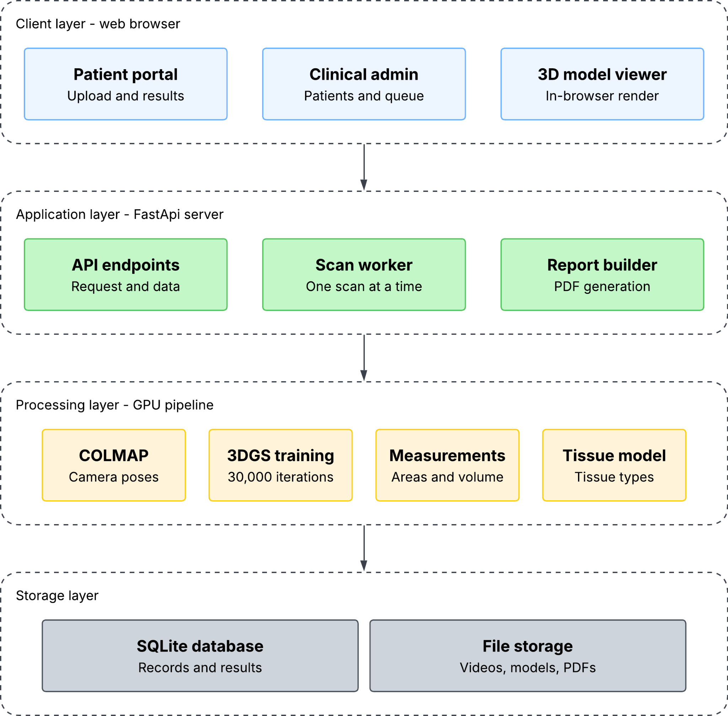

Figure 7: Wound-Splat System Architecture
Client layer. All user interaction will occur in a standard web browser. The patient portal allows the patient to sign in with their provided assigned patient code, upload a wound video, observe processing status, and view the completed results. The clinical administration view will allow the staff to register patients and monitor their processing queue. The viewer will render the reconstructed model interactively in the browser, so a completed scan can be rotated in any axis and inspected without installing a specialized software. No reconstruction, measurement, or model inference occurs in this layer.
Application Layer. The FastAPI server provides endpoints for patient records, scan submission and retrieval, tissue analysis, reconstructed outputs, measurements, and reports. When a video is submitted, the server validates the request, stores the uploaded file, creates a scan record with a queued status, and submits the scan identifier to an internal queue. A background thread subsequently executes the reconstruction pipeline. The upload request therefore does not wait for reconstruction to finish, although its duration still depends on the video size, connection speed, and storage performance.
The background worker processes reconstruction jobs sequentially to reduce simultaneous demand on the development GPU. While one reconstruction is active, the remaining scan identifiers stay in the internal queue. Sequential processing reduces memory contention between reconstruction jobs but does not prove that all concurrent jobs would fail. It also does not prevent a single large scan, a simultaneous tissue-analysis request, or another GPU process from exceeding the available memory.
Processing Layer. This layer contains the reconstruction pipeline and the separate tissue-inference service. The reconstruction worker executes frame extraction, camera-pose estimation, 3D Gaussian Splatting optimization, preview rendering, wound-region isolation, scale calibration, geometric measurement, and initial report generation. Tissue inference is initiated separately after reconstruction, when an operator selects a rectangular region from a completed scan’s video frame.
Storage layer. Structured patient, scan, measurement, and tissue-result records are stored in an SQLite relational database. Uploaded videos, extracted frames, point clouds, Gaussian models, rendered previews, tissue overlays, meshes, and PDF reports are stored in the file system. These files are located using stored paths or scan-based directory and file-naming conventions. Storage consumption varies according to the video, number of extracted frames, reconstruction density, and generated outputs; therefore, storage requirements should be reported from measured scan records rather than treated as a fixed amount.

Processing Pipeline Design
The reconstruction pipeline is the fixed sequence of seven stages, presented in Figure 3. The sequence is fixed rather than configurable because each stage consumes the output of its predecessor. Camera poses cannot be estimated before frames exists, optimization cannot begin before camera poses are known, and the wound cannot be measured before it has been isolated.
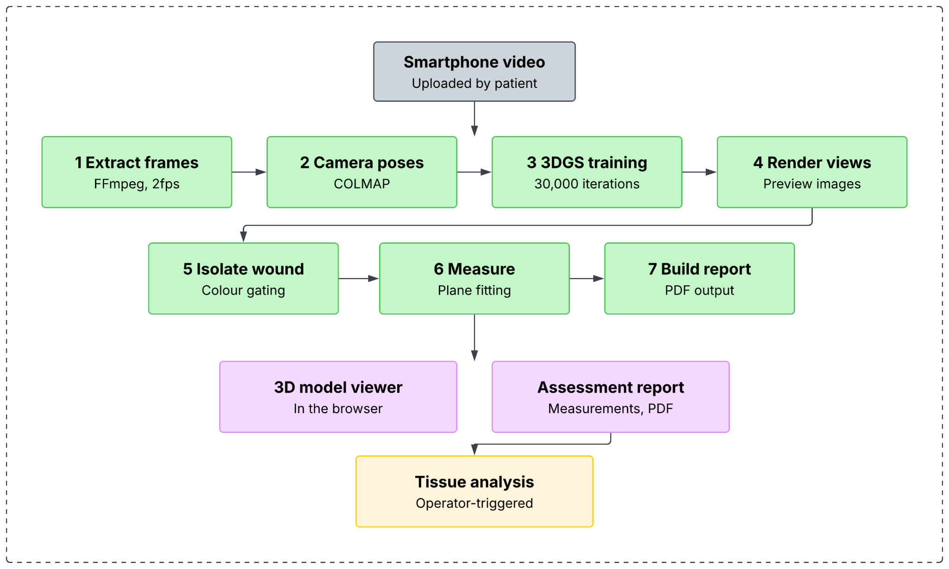

Figure 8: Seven-Stage Processing Pipeline
The reconstruction pipeline updates the scan record with its current stage, descriptive label, and progress estimate. The browser periodically retrieves this information and displays the processing status to the user. During 3D Gaussian Splatting optimization, reported training progress is parsed and recorded. COLMAP progress is estimated from its database state, while the final number of extracted and registered frames is retained separately. These indicators communicate processing activity but do not represent an exact remaining-time estimate or guarantee that the completed reconstruction is geometrically accurate.
Exceptions propagated by required processing stages mark the affected scan as failed, store an error message, and allow the worker to continue with another queued scan. However, not every auxiliary operation follows identical failure handling. Failure to detect a usable reference object normally produces an uncalibrated result rather than a failed scan, while some optional rendering and filtering operations do not consistently propagate an error to the scan record. These cases must be evaluated separately rather than described as uniform pipeline failures.
Tissue analysis is deliberately not in the pipeline stage. This is one structural exception in the design, shown as the dashed branch in Figure 3, and the reasoning is that tissue characterization requires an operator to indicate the wound region on a selected frame. The worker, however, processes queued scans unattended and one at a time. A stage that waits for human input would hold the queue open indefinitely and block every scan behind it.
Tissue analysis is a separate action available after a scan reaches rendered status. The reconstruction pipeline produces the initial PDF report before an operator selects a tissue-analysis region. After successful tissue inference, the tissue result and selected region are stored, and the system attempts to rebuild the report with the tissue percentages. If report rebuilding fails, the tissue result remains stored, but the downloadable report may continue to contain the previous information. Report synchronization must therefore be included in functional testing.

Database Design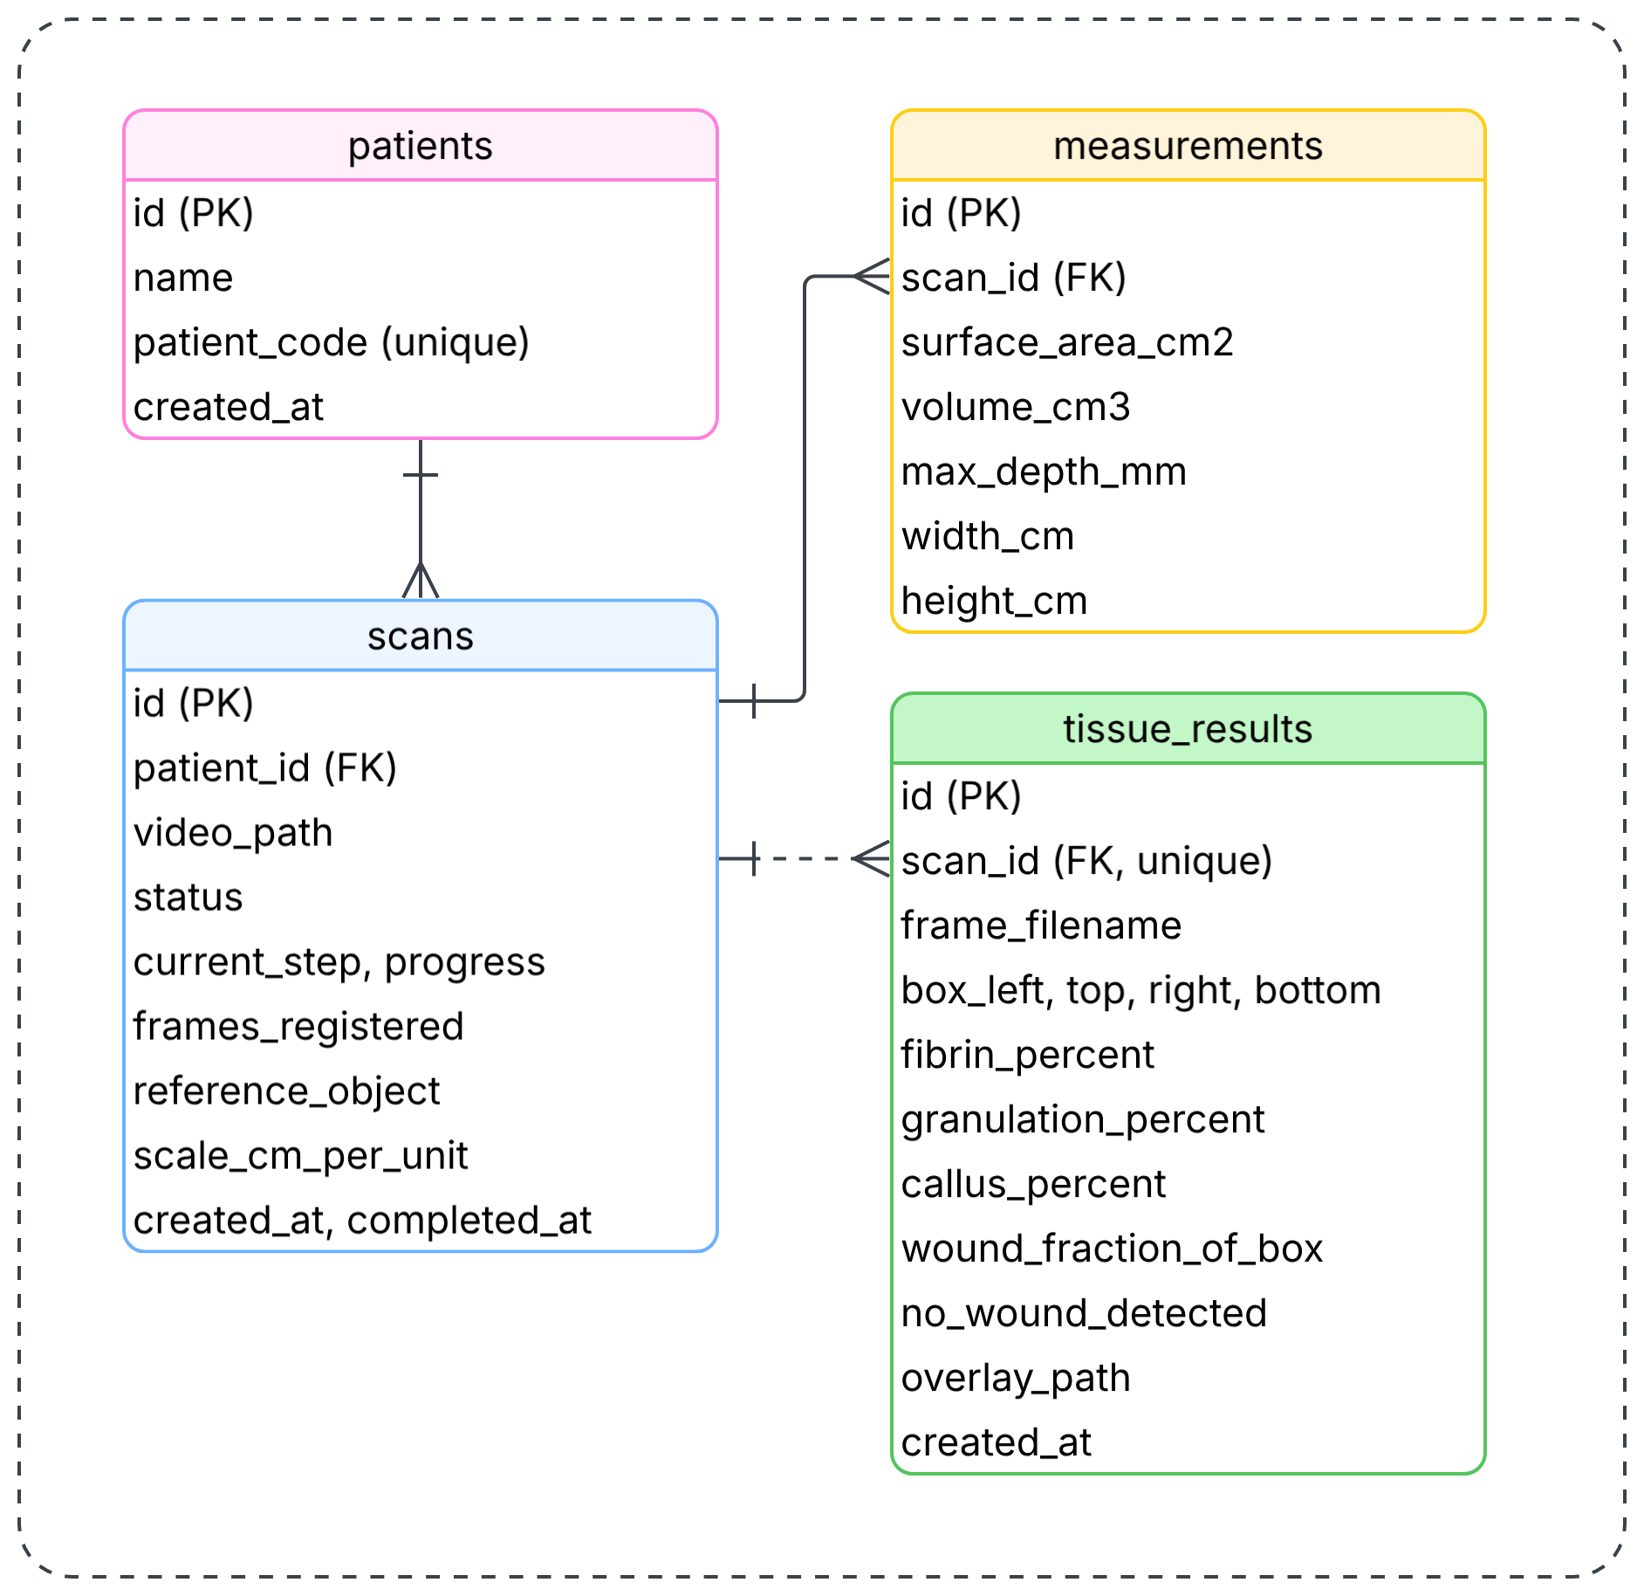Figure 9: Database Entity Relationship Diagram
Patients and scans. The Patient table stores the patient identifier, name, unique patient code, and record-creation date. A patient may have multiple scan records, while each scan belongs to one patient. The Scan table stores the uploaded-video information, processing status, progress information, reconstruction statistics, reference-object selection, scale factor, output location, and error details. The patient-to-scan relationship supports retrieval of previous scans but does not by itself implement longitudinal wound tracking. The current schema has no wound identifier, visit entity, spatial-registration result, or explicit method of determining whether two scans represent the same wound.
To support Objective 2, a future schema extension will need to associate each scan with a specific wound and clinical visit. It will also need to preserve the scans used in each comparison, the selected registration method, alignment parameters, registration-quality indicators, and calculated changes in wound measurements. These records are not part of the current database and must be described as planned rather than implemented.
Scan records. The scan entity will carry three groups of fields that serve distinct purposes. The first identifies the uploaded video and the resulting output location. The second tracks the processing state—status, current stage, and completion percentage—and is what the client polls for progress. The third records the conditions under which measurement was performed: which reference object was used for calibration and the resulting conversion factor between model units and centimeters.
Recording the calibration factor on the scan rather than disregarding it after use is a deliberate choice. It makes every measurement traceable to the calibration that produced it, and it permits an explicit representation of the uncalibrated case. Where no reference object is detected, this field is left empty rather than defaulted, and the interface and report present the affected measurements as approximate rather than clinical values.
Measurements and Tissue Results. The application expects a single current measurement result and a single current tissue result for each scan. The Measurement table stores surface area, volume, maximum depth, width, and height. However, its scan_id foreign key is not currently unique at the database level, meaning the schema can technically contain more than one measurement row for a scan. The TissueResult table enforces a unique scan_id and therefore permits only one current tissue result for each scan. Repeating tissue analysis updates the existing result rather than creating a history of previous analyses.
The tissue-result record includes the analyzed frame filename, rectangular selection coordinates, predicted tissue percentages, predicted wound fraction, no-wound indicator, and overlay path. Retaining the frame and region allows the same input area to be submitted again. Nevertheless, obtaining an identical result also depends on retaining the same source image, preprocessing procedure, model architecture, model checkpoint, software environment, and inference settings.
The fibrin, granulation, and callus percentages use pixels predicted as wound tissue as their denominator and therefore total approximately 100 percent, subject to rounding. The wound_fraction_of_box field separately records the proportion of the selected rectangle classified as wound tissue. Although background pixels are excluded from the tissue-percentage calculation, changing the selected rectangle can alter the image context, resizing, model predictions, and resulting tissue composition. When fewer than one percent of the selected pixels are predicted as wound tissue, the system records a no-wound result and leaves the three tissue-percentage fields empty rather than assigning zero values.
Tissue results are held in a separate entity rather than as additional columns on the Scan record. The database schema is created by generating any tables that do not yet exist, a mechanism that will introduce a new table but will not add a column to an existing table. Placing the tissue field in their own entity therefore allows the feature to be introduced without any modifications or rebuilding a database already containing scan records.
The current database stores only the latest tissue analysis for each scan and does not preserve earlier selected regions or prediction histories. It also contains no account, password, session, access-role, wound, visit, longitudinal comparison, or clinical-classification tables. Therefore, the database supports the present prototype workflow but does not yet provide secure role-based access, complete audit history, longitudinal wound registration, or storage of Wagner and University of Texas classification support.

Project Development

Development Model
The framework was developed following the iterative and incremental model. The development proceeds through repeated cycles; each cycle produces a working addition to the system. That addition is measured against a refined criterion, and the measurement determines whether the work is retained, revised, or discarded before the next cycle even begins.
This model was selected over a linear approach because the central components of the framework cannot be specified correctly in advance. The accuracy of the reconstruction method, the reliability of a calibration routine, and the performance of the trained segmentation model are not knowable from their design; they are established by building the component and measuring it. A linear model assumes requirements are known before implementation begins, an assumption that the project could not satisfy.
The iterative model was applied to Wound-Splat by dividing development into functional components that could be designed, implemented, tested, and refined separately. These components included the reconstruction pipeline, wound-region isolation, scale calibration, geometric measurement, web application, database, three-dimensional viewer, tissue-characterization module, and report-generation process. Results from component and workflow checks were used to revise the affected modules before they were integrated into the complete prototype.


Figure 10: Iterative Development Model Applied to Wound-Splat
One rule will govern the cycle and distinguish it from a linear sequence: an iteration is not complete when the code works, but rather when the result has been measured and a decision has been taken. The measurement may show that the addition performs adequately, in which case it is retained. It may show it performs inadequately, in which case it is revised. It may also show the addition does not justify its cost, in which case it is removed. All three outcomes occurred during development and are documented. The Wound-Splat framework development is executed through the following iterative phases:
Initial Planning & Requirements: The researchers established the clinical and technical requirements for diabetic foot ulcer monitoring. This included identifying the constraints of capturing video on standard RGB smartphones and defining the specifications for the necessary hardware and software, such as the 6GB VRAM limit for local processing and the dependencies for the 3D Gaussian Splatting (3DGS) implementation.
Analysis & Design: During this phase, the system architecture was structured into a client-server model to decouple the user interface from the computationally demanding reconstruction process. The web-based client was designed to handle video uploads and display 3D models and PDF reports, while the backend logic was designed to manage the serialized worker queue, the Structure-from-Motion (SfM) pipeline via COLMAP, and the 3DGS optimization.
Implementation & Development: The model and web application were developed incrementally. The backend pipeline was implemented using Python, incorporating FFmpeg for frame extraction, PyTorch for tensor computations, and custom CUDA extensions for 3DGS rasterization. Parallel development focused on building the Next.js frontend and ensuring seamless API communication with the FastAPI server for real-time progress polling.
Testing & Evaluation: Component and workflow tests were conducted during development to assess measurement calculations, tissue-model behavior, database operations, API responses, report generation, and application workflows. Synthetic point clouds were passed directly to the geometric measurement routine and compared with analytically defined targets. Tissue predictions were evaluated using the labeled DFUTissue masks, while development reconstructions were used to confirm that the integrated workflow could process and display a scan. These tests do not establish the physical end-to-end measurement accuracy of the complete video-to-reconstruction pipeline. The optional Poisson mesh was retained for visualization, while geometric measurements were calculated separately from the filtered point cloud using the heightfield procedure.
Deployment (Review): Functional increments were integrated into the main application and reviewed using component and workflow checks. The prototype was operated in the local development environment, while deployment scripts were prepared for manually running the application on a compatible headless cloud GPU environment when required. A formal software-quality evaluation using selected ISO/IEC 25010:2023 characteristics is described separately under Project Evaluation. Development checks are not treated as completed respondent evaluation, clinical validation, or proof of full conformity with the standard.
The implemented prototype includes patient and scan management, smartphone-video upload, queued reconstruction, wound-region isolation, scale calibration, geometric measurement, interactive visualization, tissue characterization, and PDF report generation. Longitudinal registration under Objective 2 and evidence-based Wagner and University of Texas classification support under Objective 3 remain planned components. Their design may be documented in the succeeding methodology sections, but they are not treated as completed prototype functions or evaluated outputs in Thesis 1.

Multiple Constraints and Trade-off Analysis

Constraint Definition
This section defines the criteria that will be used to evaluate the Wound-Splat framework under its hardware, reconstruction, measurement, and dataset constraints. The evaluation focuses on processing time, image-registration success, and geometric measurement error, scale calibration, tissue-segmentation performance, and pipeline reliability. These criteria will be used to determine whether the framework can produce consisten results from standard smartphone videos while operating on the available computing hardware.
Tprocess = tcompleted − tstarted
Formula 1: Processing Time
Processing time measures the duration required for the system to process one wound scan. It begins when the scan enters active processing and ends when reconstruction, wound isolation, measurement, rendering, and report generation have been completed.
Where:
- Tprocess = total active processing time;
- tstarted = time at which active scan processing begins; and
- tcompleted = time at which required outputs are completed.
Queue waiting time must be recorded separately because the system processes reconstruction jobs sequentially. This prevents scans waiting in the queue from being interpreted as having longer computational processing times.
Rreg = (Nregistered / Nextracted) × 100
Formula 2: Registration Rate
Registration rate measures the proportion of video frames successfully registered by COLMAP. A higher registration rate indicates that more extracted frames contributed to camera-pose estimation and sparse reconstruction.
Where:
- Rreg = frame-registration rate;
- Nregistered = number of frames successfully registered by COLMAP; and
- Nextracted = total number of frames extracted from the uploaded video.
A high registration rate does not independently confirm geometric accuracy. The reconstructed output must also be inspected for incomplete surfaces, duplicated structures, floating points, and deformation.
Epct = (|x̂ − xref| / |xref|) × 100
Formula 3: Percentage Error
Percentage error measures the difference between a wound measurement generated by the system and its corresponding ground-truth value. It will be applied to wound opening area, cavity volume, maximum depth, width, and height when a known physical or analytical reference is available.

Where:
- Epct = percentage error;
- x̂ = measurement generated by Wound-Splat; and
- xref = known reference or ground-truth measurement.
A lower percentage error indicates that the generated measurement is closer to the reference value. Percentage error will not be calculated when the reference value is zero because this would produce an undefined denominator.
MAPE = (1 / n) × Σ |(x̂i − xref,i) / xref,i| × 100
Formula 4: Mean Absolute Percentage Error
Where:
- MAPE = mean absolute percentage error;
- n = number of valid test samples;
- x̂i = system-generated measurement for sample i; and
- xref,i = ground-truth measurement for sample i.
The current synthetic-phantom test uses a maximum error tolerance of 10% for each evaluated geometric quantity. This criterion verifies the internal measurement calculations for the analytically defined point cloud. It does not validated the complete smartphone video-to-measurement pipeline.
s = Lreal / Lmodel
Formula 5: Scale Calibration
Scale calibration converts dimensions from arbitrary reconstruction units into physical units. A supported card or coin with a known dimension is placed near the wound and used as the reference object.
Where:
- s = scale factor in centimeters per model unit;
- Lreal = known physical dimension of the reference object; and
- Lmodel = corresponding reference-object dimension measured in reconstruction units.
The scale factor is applied differently according to the dimensional property being converted.
For length and depth:
Lcm = s × Lmodel
For area:
Acm² = s² × Amodel
For volume:
Vcm³ = s³ × Vmodel
Where:
- Lcm = calibrated length or depth in centimeters;
- Acm² = calibrated area in square centimeters; and
- Vcm³ = calibrated volume in cubic centimeters.

Scale calibration is sensitive to reference-object visibility, blur, glare, occlusion, perspective distortion, and incorrect reference selection. When a reliable scale cannot be obtained, physical measurements must be identified as uncalibrated.
Dice = 2TP / (2TP + FP + FN)
Formula 6: Dice Similarity Coefficient
Where:
- TP = pixels correctly assigned to the tissue class;
- FP = pixels incorrectly assigned to the tissue class; and
- FN = pixels belonging to the tissue class that were not identified.
A Dice score of 1 indicates complete overlap between the predicted and ground-truth regions. A value closer to 0 indicates weaker overlap.
IoU = TP / (TP + FP + FN)
Formula 7: Intersection over Union
Where:
- TP = correctly classified tissue pixels;
- FP = pixels incorrectly included in the tissue class; and
- FN = tissue pixels omitted by the prediction.
Dice and intersection over union will be reported for the available tissue classes. Their interpretation must consider that the DFUTissue contains only 110 labeled images and does not provide labels for every tissue appearance that may occur in clinical wounds.

Rcomplete = (Ncompleted / Nsubmitted) × 100
Formula 8: Pipeline Completion Rate
Pipeline completion rate measures the proportion of submitted scans that successfully produce the required reconstruction and report outputs.
Where:
- Rcomplete = pipeline completion rate;
- Ncompleted = number of scans that complete all required processing stages; and
- Nsubmitted = total number of submitted scans included in the test.
A scan that fails because of insufficient image overlap, unavailable camera poses, reconstruction errors, or another required-stage failure will be counted as unsuccessful. A scan that completes without physical scale calibration may still produce a visual reconstruction, but its size-dependent measurements must be identified as uncalibrated.

Design Trade-offs
The study analyzes the trade-offs involved in selecting the methods used for wound reconstruction, visualization, measurement, and tissue characterization. The reconstruction methods considered during the architectural analysis include Structure-from-Motion with 3D Gaussian Splatting, Multi-View Stereo reconstruction, Neural Radiance Fields, and Structure-from-Motion alone. The measurement representations considered include a filtered point-cloud heightfield, a Poisson-reconstructed mesh, and a raw sparse point cloud.
The comparison focuses on reconstruction output, computational demand, suitability for interactive visualization, compatibility with geometric measurement, and feasibility on the available NVIDIA RTX 4050 Laptop GPU with 6 GB of video memory. The comparison provides a technical justification for the architecture selected for Wound-Splat
Method | Primary Output | Main Advantage | Main Limitation | System Use
Structure-from-Motion with 3D Gaussian Splatting | Camera poses, sparse Initialization. And Gaussian-splat representation | Produces an interactively renderable three-dimensional representation after optimization | Requires substantial GPU processing and does not directly provide a watertight measurement surface | Selected for reconstruction and interactive visualization
Multi-View Stereo | Dense point cloud or surface derived from matched image features | Can produce an explicit dense geometric representation | Sensitive to weak texture, reflections, occlusion, and inconsistent lighting | Retained as a possible comparison method for later controlled evaluation
Neural Radiance Fields | Continuous neural scene representation | Supports novel-view rendering and continuous scene representation | Training and rendering can be computationally demanding, while metric geometry still requires validation | Not implemented in the current prototype
Structure-from-Motion | Sparse point cloud and camera pose | Requires fewer reconstruction stages than a complete neural rendering pipeline | Sparse geometry may not contain sufficient wound surface detail for measurement | Used for camera estimation and 3DGS initialization

Table 8: Comparison of Three-Dimensional Reconstruction Methods
The selected pipeline combines COLMAP Structure-from-Motion with 3D Gaussian Splatting. COLMAP estimates the camera positions and produces the sparse initialization required by the 3DGS optimization. The Guassian-splat representation is then used in the browser viewer because it supports interactive inspection from different viewpoints.
The selection does not establish that 3DGS is more geometrically accurate than every alternative. Its advantage within the current framework is its compatibility with the implemented pipeline and its ability to provide an interactive visual representation. Controlled testing is still required to determine how accurately the complete reconstruction preserves wound dimensions.
Representation | Measurement Approach | Main Advantage | Main Limitation | System Use
Filtered point-cloud height field | Fits a periwound reference plane and measures the wound cavity using median grid depths | Avoids measuring directly from a smoothed mesh and supports the calculation of area, volume,d epth, width, and height | Sensitive to point density, grid resolution, hole filling, and reference-plane estimation | Selected measurement representation
Poisson-reconstructed mesh | Constructs a continuous surface from oriented points | Produces a smoother surface that is easier to inspect visually | Surface smoothing and hole closure may alter the shape of the wound cavity | Optional visualization only
Raw sparse point cloud | Measures directly from COLMAP sparse point | Required no additional surface construction | Main contain insufficient point density for stable wound measurement | Not used as the final measurement representation
Gaussian-splat representation | Represents the scene using optimized Gaussian primitives | Provides interactive rendering | designed primarily for rendering and does not directly define a validated measurement surface | Used for visualization while measurements are derived from the isolated point cloud

Table 9: Comparison of Geometric Measurement Representations
The point-cloud heightfield was selected as the measurement representation because the optional POssing mesh may smooth the wound boundary or artificially close gaps in the reconstructed surface. The heightfield estimates the wound cavity relative to a reference plane fitted to the surrounding periwound region. However, this method assumes that the wound surface can be represented by one depth value for each grid location.
For spatial wound isolation, the current system uses opacity filtering, outlier removal, spatial clustering, color evidence, and a periwound margin. This avoids the immediate requirement for a labeled three-dimensional wound dataset. The corresponding limitation is that the isolated region may be affected by shadows, glare, exudate, weak color separation, or reconstruction noise.
For two-dimensional tissue characterization, the system uses an operator-selected rectangular region. This allows the clinician to identify the relevant wound region without requiring a separate automatic wound-localization model. However, the resulting tissue percentages may change when the selected frame or rectangular region changes, the selected frame, region, predicted wound fraction and the tissue percentages must therefore be retained with the result.

Trade-off Analysis
This section presents the method that will be used to compare the evaluated configurations according to predefined criteria. Each configuration will be compared with the best-performing configuration for every criterion. The leader will receive a criterion rank of 10, while the remaining configuration will receive proportional ranks.
The criteria will include geometric measurement error, processing time, peak GPU-memory consumption, registration rate, completion rate, Dice, and Intersection over Union are considered benefit criteria because higher values are preferred.

RDbenefit = (B − V) / B
Formula 9: Relative Difference for Benefit Criteria
Where:
- RDbenefit = relative difference for a benefit criterion;
- B = best or highest observed value; and
- V = value of the configuration being evaluated.
Rbenefit = 10 × (1 − RDbenefit)
Formula 10: Benefit-Criterion Rank
The configuration with the highest observed value receives a rank of 10.
RDcost = (V − B) / V
Formula 11: Relative Difference for Cost Criteria
For criteria where a lower value indicates better performance, relative difference is calculated as follows:
Where:
- RDcost = relative difference for a cost criterion;
- B = best or lowest observed value; and
- V = value of the configuration being evaluated.
Rcost = 10 × (1 − RDcost)
Formula 12: Cost-Criterion Rank
The configuration with the lowest observed cost receives a rank of 10. This form prevents configurations with higher processing time, memory consumption, or measurement error from receiving negative ranks.
Criterion | Type | Measurement | Preferred Result
Geometric measurement error | Cost | Mean percentage error for area, volume, depth, width and height | Lower
Processing time | Cost | Active processing duration per scan | Lower
GPU memory consumption | Cost | Peak GPU memory recorded during reconstruction | Lower
Registration rate | Benefit | Percentage of extracted frames registered by COLMAP | Higher
Pipeline completion rate | Benefit | Percentage of submitted scans producing the required outputs | Higher
Tissue-segmentation performance | Benefit | Dice and Intersection over Union | Higher

Table 11: Evaluation Criteria for the Trade-Off Analysis
The result tables of these criteria will be completed after the controlled experiments are conducted in Thesis 2. No numerical rank is assigned in Thesis 1 because comparative runtime, memory consumption, and complete physical accuracy measurements have not yet been collected for all configurations.
The current architectural selection prioritizes geometric traceability and stable operation on the available hardware. Reconstruction jobs are processed sequentially to reduce GPU-memory contention, this limits throughput but lowers the likelihood of simultaneous jobs exhausting the available 6 GB of video memory.
The optional Poisson mesh is retained for visual inspection, while wound measurements are calculated from the isolated point cloud and heightfield. This separates visual smoothness from measurement calculation and prevents the displayed mesh from automatically being treated as a validated wound surface.

Sensitivity Analysis
A sensitivity analysis will be conducted to determine whether the preferred configuration changes when different evaluation criteria are assigned greater importance. The criteria used in this analysis are geometric accuracy, processing efficiency, resource efficiency, and pipeline reliability.
Each criterion will be assigned a criterion weight. The sum of the weights for one trail equals 1.00. The criterion score will be obtained by dividing the criterion rank by 10 so that all criterion scores range from 0 to 1.
CS = R / 10
Formula 13: Criterion Score
WCS = CS × CW
Formula 14: Weighted Criterion Score
Where:
- WCS = weighted criterion score;
- CS = normalized criterion score; and
- CW = assigned criterion weight
Stotal = Σ(CSj × CWj), for j = 1 to m
Formula 15: Total Weighted Score
Where:
- Stotal = total weighted score of the evaluated configuration;
- m = number of evaluation criteria;
- CSj = normalized score for criterion j; and
- CWj = weight assigned to criterion j.
The configuration with the highest total weighted score represents the strongest balance under the priorities of the corresponding trial.

Trial | Geometric Accuracy | Processing Efficiency | Resource Efficiency | Pipeline Reliability | Total Weight
Trial 1: Accuracy Bias | 0.50 | 0.15 | 0.10 | 0.25 | 1.00
Trial 2: Processing-Efficiency Bias | 0.25 | 0.40 | 0.20 | 0.15 | 1.00
Trial 3: Resource Efficiency Bias | 0.25 | 0.15 | 0.45 | 0.15 | 1.00
Trial 4: Reliability Bias | 0.30 | 0.10 | 0.10 | 0.50 | 1.00
Trial 5: Balanced | 0.25 | 0.25 | 0.25 | 0.25 | 1.00

Table 12: Criterion Weights for the Sensitivity-Analysis Trials
Trial 1 prioritizes geometric accuracy by assigning it a weight of 0.50. This trial determines which configuration is most suitable when preserving wound dimensions is the primary concern.
Trial 2 prioritizes processing efficiency. It evaluates whether a faster configuration can provide acceptable geometric and reliability results when processing time is given greater importance.
Trial 3 prioritizes resource efficiency. This trial is relevant to the 6 GB GPU limitation and determines which configuration uses the available computing resources most effectively.
Trial 4 prioritizes pipeline reliability. It gives greater importance to successful frame registration, completed reconstructions, and the production of the required outputs.
Trial 5 assigns equal importance to all criteria. It provides a balanced assessment without favoring accuracy, processing time, resource consumption, or reliability.
The criteria and procedures defined in this section establish the evaluation protocol that will be applied to the completed system in Thesis 2. Thesis 1 covers the system design, implementation methodology, and available component-level verification. The complete experimental results, trade-off rankings, sensitivity-analysis results, and their interpretation will be presented in Chapters 4 and 5.

Synthetic point-cloud experiments may be used to verify the measurement calculations, but they will not be treated as validation of smartphone capture, COLMAP registration, 3D Gaussian Splatting reconstruction, automatic wound isolation, or scale calibration as a complete pipeline.
Longitudinal wound registration under Objective 2 and Wagner and University of Texas classification support under Objective 3 remain planned components. Their performance and sensitivity will be evaluated separately after they are implemented. No longitudinal-registration or ulcer-classification results are claimed for the current prototype.

Testing and Operating Procedure
The Wound-Splat framework is designed to operate within a client-server environment, requiring distinct operational procedures for the patient and the clinical administrator. The patient initiates the workflow by accessing the patient portal via a standard web browser, authenticating with an assigned patient code, and uploading a wound video. The upload protocol mandates that the video includes a visible scale reference (e.g., a standard bank card) and captures the wound from multiple overlapping angles. Upon upload, the system immediately returns a tracking identifier. The patient can subsequently poll the system to monitor the seven-stage processing pipeline. Once the pipeline reaches the "rendered" status, the patient can access the interactive 3D viewer to inspect the Gaussian splat model and download the generated PDF assessment report.
Concurrently, the clinical administrator operates the backend dashboard to manage patient registrations, monitor the serialized GPU processing queue, and perform tissue characterization. Because tissue analysis requires human-in-the-loop region selection, the clinician accesses the rendered scan, draws a boundary around the wound on a selected 2D frame, and triggers the tissue segmentation inference. The system then regenerates the final PDF report to include the tissue percentages alongside the geometric measurements.

Project Evaluation
The evaluation design of the system is grounded in the ISO/IEC 25010:2023 Systems and Software Quality Requirements and Evaluation (SQuaRE) model, which provides a standardized framework for assessing software product quality. This internationally recognized standard evaluates the functionality, reliability, usability, and overall quality of the system, making it ideal for a healthcare-focused framework that processes sensitive wound imagery and generates clinical decision-support metrics.
The following criteria will be used for the evaluation:
Functional Suitability. The system is designed to address the specific needs of both diabetic patients and healthcare providers by delivering accurate, volumetric wound assessments using standard smartphone videos. It integrates 3D Gaussian Splatting (3DGS) reconstruction with 2D tissue segmentation to ensure that geometric measurements and tissue characterizations are both clinically relevant. The system also provides essential details such as wound volume, depth, surface area, and mapped Wagner and University of Texas classification suggestions. For clinicians, it serves as an accessible decision-support tool to monitor healing trajectories without requiring specialized, expensive 3D medical scanners.
Functional Correctness. The framework ensures the provision of correct results and precise measurements through its rigorously tested computational pipeline. The geometric accuracy of the 3D reconstruction and the absolute scale calibration routine are validated against physical rigid objects of known dimensions and synthetic wound phantoms (spherical caps, half-ellipsoids, and shallow craters) with analytically known ground truths. By measuring the raw segmented point cloud rather than the smoothed Poisson mesh, the system minimizes geometric degradation, ensuring that the extracted volumetric and spatial metrics precisely reflect the actual wound geometry without artificial smoothing.
Performance Efficiency. The system is optimized to utilize available hardware resources effectively while managing user expectations during computationally intensive tasks. Although a complete 3D Gaussian Splatting reconstruction requires significant GPU processing, the framework employs a serialized background worker queue that prevents memory exhaustion on consumer-grade hardware (e.g., 6GB VRAM). For scans that exceed local memory limits, the system dynamically utilizes the provisioned 48GB cloud instance. The application maintains performance efficiency by providing real-time progress polling to the client, ensuring that the user interface remains responsive and does not time out while the backend processes the seven-stage pipeline across the hybrid hardware environment.
Reliability. The framework is designed to maintain a specified level of performance and availability under stated conditions, particularly when handling variable-quality smartphone inputs. If a stage in the processing pipeline fails, such as insufficient visual overlap for Structure from Motion (SfM) or failure to detect the scale reference object, the system isolates the error, marks the specific scan record as "failed" with a descriptive log, and safely advances the queue to the next scan. This fault-tolerant architecture ensures that a single corrupted upload or processing anomaly does not crash the background worker or disrupt the availability of the web application for other users.
Safety. The system incorporates safeguards to prevent unacceptable risks of harm to patients or data breaches, recognizing its role as a clinical decision-support tool rather than an autonomous diagnostic device. To ensure clinical safety, the framework explicitly flags uncalibrated measurements as "approximate" when the reference object is not detected, preventing clinicians from making critical decisions based on arbitrary model scaling. Furthermore, the system is designed to handle sensitive health information securely, ensuring that patient data and wound imagery are stored in a protected relational database with strict access controls, and all generated outputs clearly distinguish automated algorithmic suggestions from confirmed clinical diagnoses.

Survey Questionnaire for Non-Information Technology Respondents
Criteria | Rating
Functional Suitability - Assesses whether the system provides accurate and relevant wound assessment features based on 3D reconstruction and clinical measurement standards, and presents results clearly enough to support clinical decision-making. | 6 | 5 | 4 | 3 | 2 | 1
1. The system accurately reconstructs three-dimensional wound models from smartphone video using Structure from Motion (SfM) and 3D Gaussian Splatting (3DGS) algorithms.
2. The system correctly extracts geometric measurements (volume, depth, surface area) from the reconstructed point cloud and maps them to Wagner and University of Texas classification systems.
3. The system produces consistent and complete outputs across both user roles (Patient and Clinical Administrator), with each role correctly restricted to its intended features and data access.

Criteria | Rating
Functional Correctness - Assesses whether the system provides correct results and precise measurements through validated computational methods and ground-truth comparison. | 6 | 5 | 4 | 3 | 2 | 1
1. The system's volumetric and spatial measurements correspond accurately to known ground-truth dimensions when validated against synthetic wound phantoms and rigid calibration objects.
2. The system correctly identifies and isolates the wound region from surrounding skin and background, ensuring that measurements are restricted to the actual wound boundary.
3. The tissue characterization model generates correct and clinically relevant tissue percentages (fibrin, granulation, callus) for the identified wound area.

Criteria | Rating
Performance Efficiency - Assesses how efficiently the system uses device resources while maintaining responsiveness during reconstruction and risk prediction tasks on the web application. | 6 | 5 | 4 | 3 | 2 | 1
1. The system processes video uploads and completes the seven-stage reconstruction pipeline within the target timeframe on consumer-grade GPU hardware.
2. The serialized background worker queue effectively manages GPU memory consumption and prevents system crashes when multiple scan requests are submitted.
3. The system operates efficiently on the designated hardware, consuming minimal CPU and memory resources without causing browser or system instability during processing.

Criteria | Rating
Reliability - Assesses the system's ability to maintain a specified level of performance under stated conditions and handle failures appropriately. | 6 | 5 | 4 | 3 | 2 | 1
1. The system maintains consistent performance and availability when processing multiple scan requests through the serialized queue without data loss or corruption.
2. The system correctly handles and reports errors when reconstruction stages fail (e.g., insufficient visual overlap, reference object detection failure) without blocking subsequent scans.
3. The system preserves data integrity and maintains accurate scan records, measurement history, and patient information across multiple sessions and visits.

Criteria | Rating
Safety - Assesses whether the system prevents unacceptable risks of harm to patients and protects sensitive health information. | 6 | 5 | 4 | 3 | 2 | 1
1. The system clearly distinguishes automated measurement results and classification suggestions from confirmed clinical diagnoses, preventing misinterpretation as autonomous medical decisions.
2. The system appropriately flags uncalibrated measurements as "approximate" when reference object detection fails, preventing clinical decisions based on arbitrary model scaling.
3. The system protects sensitive patient wound imagery and health information through secure storage, access controls, and authorized user authentication.

Survey Questionnaire for Non-Information Technology Respondents
Criteria | Rating
Functional Suitability - Assesses whether the system provides accurate and relevant wound assessment features based on 3D reconstruction and clinical measurement standards, and presents results clearly enough to support clinical decision-making. | 6 | 5 | 4 | 3 | 2 | 1
1. The system accurately reconstructs three-dimensional wound models from smartphone video and correctly extracts geometric measurements (volume, depth, surface area).
2. The system appropriately maps measured wound parameters to Wagner and University of Texas classification suggestions based on the identified wound characteristics.
3. The system produces consistent and complete outputs across both user roles (Patient and Clinical Administrator), with each role correctly restricted to its intended features and data access.

Criteria | Rating
Functional Correctness - Assesses whether the system provides correct results and precise measurements through validated computational methods and ground-truth comparison. | 6 | 5 | 4 | 3 | 2 | 1
1. The system's volumetric and spatial measurements correspond accurately to known ground-truth dimensions when validated against synthetic wound phantoms and rigid calibration objects.
2. The system correctly identifies and isolates the wound region from surrounding skin and background, ensuring that measurements are restricted to the actual wound boundary.
3. The tissue characterization model generates correct and clinically relevant tissue percentages (fibrin, granulation, callus) for the identified wound area.

Criteria | Rating
Performance Efficiency - Assesses how efficiently the system uses device resources while maintaining responsiveness during reconstruction and risk prediction tasks on the web application. | 6 | 5 | 4 | 3 | 2 | 1
1. The system processes video uploads and delivers reconstruction results within an acceptable response time while maintaining progress visibility.
2. The system maintains stable response times during extended use or when processing complex wound models with multiple frames without affecting overall device performance.
3. The system operates efficiently on the designated GPU hardware, consuming minimal memory and CPU resources without causing browser or system instability.

Criteria | Rating
Reliability - Assesses the system's ability to maintain a specified level of performance under stated conditions and handle failures appropriately. | 6 | 5 | 4 | 3 | 2 | 1
1. The system maintains consistent performance and availability when processing multiple scan requests through the serialized queue without crashes or data loss.
2. The system correctly handles and reports errors when reconstruction stages fail (e.g., insufficient visual overlap, reference object not detected) without blocking subsequent scans.
3. The system preserves data integrity and maintains accurate scan records, measurement history, and patient information across multiple sessions and visits.

Criteria | Rating
Safety - Assesses whether the system prevents unacceptable risks of harm to patients and protects sensitive health information. | 6 | 5 | 4 | 3 | 2 | 1
1. The system clearly distinguishes automated measurement results and classification suggestions from confirmed clinical diagnoses, preventing misinterpretation as autonomous medical decisions.
2. The system appropriately flags uncalibrated measurements as "approximate" when reference object detection fails, preventing clinical decisions based on arbitrary model scaling.
3. The system protects sensitive patient wound imagery and health information through secure storage, access controls, and authorized user authentication.

Work Plan
The development and execution of the Wound-Splat framework follow a structured Work Breakdown Structure (WBS) to ensure systematic progress from conceptualization to final documentation. The project is divided into two major phases: Thesis 1 and Thesis 2.
The project commences with project planning and design, spanning the first three weeks. During this foundational stage, the research objectives and scope are finalized, and the system architecture is formalized. Key deliverables include the finalized project proposal, system architecture diagrams, and UI/UX wireframes for both the patient and clinician portals. This phase ensures that all structural and computational constraints, particularly the serialized GPU processing queue and the client-server separation, are explicitly addressed before any coding begins.
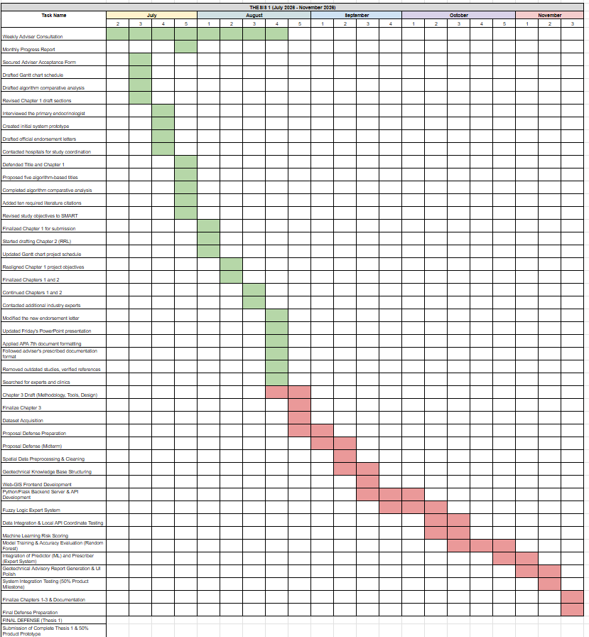

Figure 11 Work Plan Gantt Chart for Thesis 1 and Thesis 2

Potential for Commercialization
This section defines the market model and the system's commercial impact in terms of its capabilities within the Philippine healthcare ecosystem. Having established the technical architecture and computational constraints of the Wound-Splat framework, this section evaluates its viability as a deployable health-tech solution for diabetic foot ulcer monitoring.

Market Model
According to the Department of Health and the International Diabetes Federation, the rising prevalence of diabetes necessitates scalable wound monitoring solutions. The market is defined using the TAM, SAM, and SOM model to establish realistic deployment targets (International Diabetes Federation, 2024).
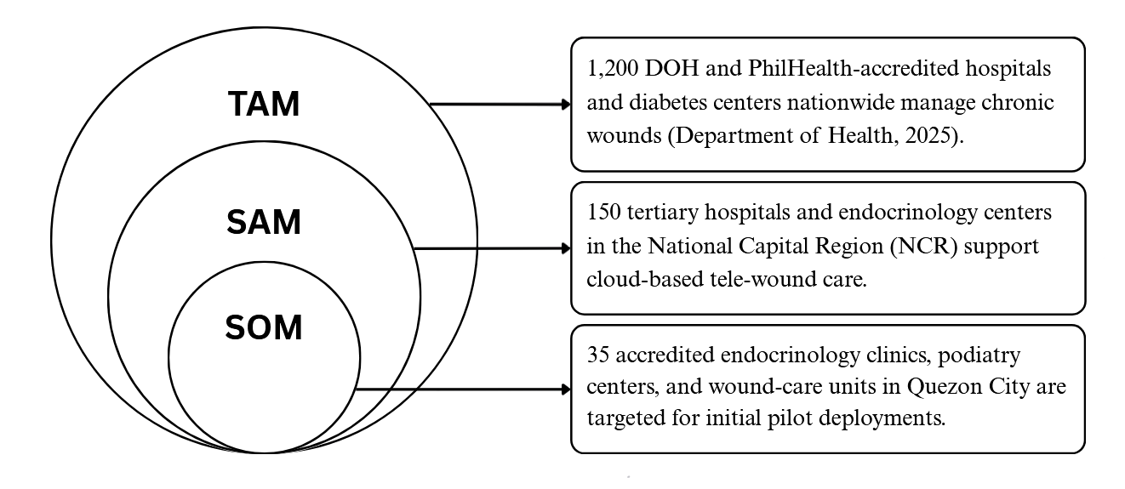

Figure 12: TAM SAM SOM Model

Measurable Benefits
The system aims to revolutionize chronic wound management by transitioning from subjective 2D photographic assessments to objective 3D volumetric tracking. Utilizing 3D Gaussian Splatting (3DGS), the framework automates the extraction of precise wound depth, surface area, and cavity volume; metrics that are critical for predicting DFU healing trajectories but impossible to capture via standard smartphone photos (Kerbl et al., 2023). Furthermore, the integration of an AI-driven tissue segmentation model automates the classification of wound etiologies (fibrin, granulation, and callus), minimizing the need for manual, subjective diagnosis by overworked clinical staff (Dhar et al., 2024). Because the heavy computational lifting is offloaded to a cloud-based serialized queue, the web-based application provides patients in resource-limited settings access to advanced 3D monitoring using only standard consumer smartphones, drastically reducing the financial and logistical burden of frequent in-person clinic visits.

Three-year Product Roadmap
The three-year product roadmap shows the development plan, platform expansion, and feature enhancements of the proposed system from the year 2027 to 2029. It provides a clear view of how the system is expected to evolve in terms of market reach, platform accessibility, and clinical capabilities.
 | 2027 | 2028 | 2029
Market | Initial clinical pilot deployments in specialized endocrinology and podiatry clinics in Quezon City. | Expansion to tertiary hospitals and medical institutions across the National Capital Region (NCR). | Full-scale B2B adoption across hospital networks and integration with national telehealth initiatives nationwide.
Platform | Web-based clinician dashboard supporting desktops/laptops, paired with a smartphone-optimized patient capture portal. | Web-based platform with enhanced API support for tablet-based ward rounds and bedside assessments. | Cross-platform enterprise application with native EMR/EHR integration and offline sync capabilities for remote areas.
Features | 3D volumetric reconstruction, automated reference-object calibration, and basic tissue segmentation reports (fibrin, granulation, callus). | Enhanced longitudinal tracking dashboard, temporal wound registration (ICP alignment), and customizable clinical reports. | Predictive healing analytics, AI-driven intervention recommendations, and expansion to other chronic wounds (e.g., venous leg ulcers).

Table 13: Three-year Roadmap Table

Go-to Market Strategy
The Go-to-Market Strategy describes how the Wound-Splat prototype will be introduced and made accessible to the target market. The strategy is split into three components: What, Who, and How.
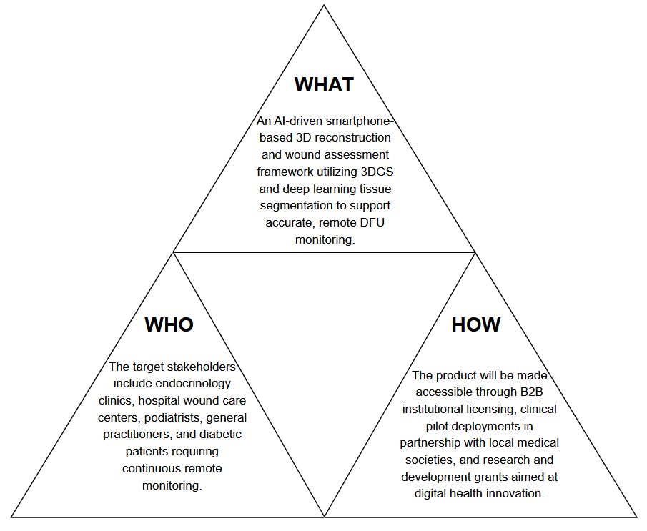

Figure 13: Go-to Market Strategy

Business Model
The Business Model of the study focuses on a B2B health-tech platform developed to assist endocrinologists and healthcare institutions in monitoring diabetic foot ulcers objectively. It leverages cloud-based 3DGS rendering and tissue segmentation models trained on specialized datasets (Dhar et al., 2024), targeting the aim of making clinical screening quicker, precise, and accessible.

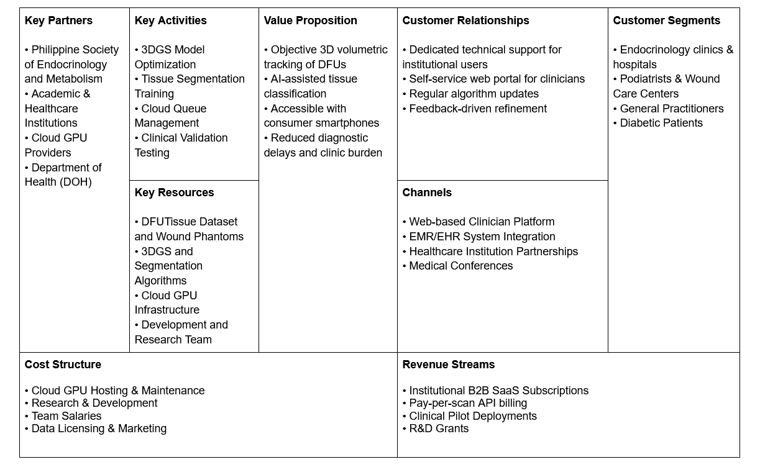Figure 14: Business Model Canvas
To make this platform a reality, the research relies on collaborations with organizations such as the Philippine Society of Endocrinology and Metabolism, the Department of Health, and academic health-tech institutions. The main tasks include optimizing the 3DGS pipeline, managing the serialized cloud-compute queue to control GPU expenses, and conducting clinical validation. Users will have access to continuous support via frequent model updates and a self-service web interface for clinicians. Financially, the platform is supported by institutional SaaS subscriptions, pay-per-scan API billing for EMR integration, and R&D grants.

References
Basiri, R., Saleh, A., Khan, S.S., Popovic, M.R. (2026). Temporal machine learning framework for diabetic foot ulcer healing trajectory prediction. Biomed Eng Online. https://doi.org/10.1186/s12938-026-01529-2
Chen, Y.-P., Long, Q.-C., Wang, H.-J., Tang, S.-S., & Lee, C.-Y. (2023). A deep learning-based segmentation strategy for diabetic foot ulcers: Combining the strengths of HarDNet-MSEG and SAM models. International Symposium on Computer, Consumer and Control. https://doi.org/10.1109/IS3C57901.2023.00107
Chierchia, R., Lebrat, L., Ahmedt-Aristizabal, D., Salvado, O., Fookes, C., & Cruz, R. S. (2025a). SALVE: A 3D reconstruction benchmark of wounds from consumer-grade videos. https://arxiv.org/abs/2407.19652
Chierchia, R., Cruz, R. S., Lebrat, L., Arzhaeva, Y., Armin, M. A., Oorloff, J., Nguyen, C., Salvado, O., Fookes, C., & Ahmedt-Aristizabal, D. (2025b). Wound3DAssist: A practical framework for 3D wound assessment. https://arxiv.org/abs/2508.17635
Chierchia, R., Lebrat, L., Ahmedt-Aristizabal, D., Arzhaeva, Y., Salvado, O., Fookes, C., & Cruz, R. S. (2026). Multi-view consistent wound segmentation with neural fields. https://arxiv.org/abs/2601.16487
Clini, P., Nespeca, R., Angeloni, R., & Coppetta, L. (2024). 3D representation of architectural heritage: A comparative analysis of NeRF, Gaussian Splatting, and SfM-MVS reconstructions using low-cost sensors. ISPRS Archives, XLVIII-2/W8-2024, 93–99. https://doi.org/10.5194/isprs-archives-xlviii-2-w8-2024-93-2024
De Waele, L., Gooijers, J., & Mantini, D. (2026). Smartphone-based automated photogrammetry for reconstruction of residual limb models in prosthetic design. Sensors, 26(4), 1251. https://doi.org/10.3390/s26041251
Flaherty, A. F., Bejarano-Pineda, L., DiGiovanni, C. W., & Ashkani-Esfahani, S. (2024). Efficacy of 3D wound assessment in predicting granulation tissue velocity following negative pressure wound therapy in diabetic foot ulcers. Foot & Ankle International. https://doi.org/10.1177/2473011424S00267
Huang, B., Li, Z., Liu, S., Tang, X., Tang, J., Lin, J., Cheng, Y., Chen, Z., Wu, X., & Wong, N. (2025). Hybrid mesh-Gaussian representation for efficient indoor scene reconstruction. Proceedings of IJCAI-25. https://doi.org/10.48550/arXiv.2506.06988
Huang, Z., Jin, Y., Wang, H., Deng, Z., Zhikai, Y., Yanzhou, S., Liu, J., Li, T., Gu, Y., Zhang, S., Qiao, Y., Gu, L., & Junjun, H. (2025). Revisiting model scaling with a U-net benchmark for 3D medical image segmentation. Scientific Reports. 15. https://doi.org/10.1038/s41598-025-15617-1
International Diabetes Federation. (2024). Philippines diabetes country report 2000–2050. IDF Diabetes Atlas. https://diabetesatlas.org/data-by-location/country/philippines/
International Working Group on the Diabetic Foot. (2023). IWGDF guideline on classification of diabetes-related foot ulcers. https://iwgdfguidelines.org/wp-content/uploads/2023/07/IWGDF-2023-03-Classification-Guideline.pdf
International Organization for Standardization. (2023). ISO/IEC 25010:2023 Systems and software engineering — Systems and software Quality Requirements and Evaluation (SQuaRE) — Product quality model. https://www.iso.org/standard/78176.html
Kabir, M. A., Samad, S., Ahmed, F., Naher, S., Featherston, J., Laird, C., & Ahmed, S. (2024). Mobile apps for wound assessment and monitoring: Limitations, advancements and opportunities. Journal of Medical Systems, 48(1), 80. https://doi.org/10.1007/s10916-024-02091-x
Kerbl, B., Kopanas, G., Leimkühler, T., & Drettakis, G. (2023). 3D Gaussian Splatting for real-time radiance field rendering. ACM Transactions on Graphics, 42(4), 1–14. https://arxiv.org/abs/2308.04079
Kryvoshei, O., Kamencay, P., & Polak, L. (2026). Neural vessel segmentation and Gaussian Splatting for 3D reconstruction of cerebral angiography. AI, 7(1), 22. https://doi.org/10.3390/ai7010022
Lebrat, L., Santa Cruz, R., Chierchia, R., Arzhaeva, Y., Armin, M. A., Goldsmith, J., Oorloff, J., Reddy, P., Nguyen, C., Petersson, L., Barakat-Johnson, M., Luscombe, G., Fookes, C., Salvado, O., & Ahmedt-Aristizabal, D. (2024). Syn3DWound: A synthetic dataset for 3D wound bed analysis. IEEE International Symposium on Biomedical Imaging. https://doi.org/10.1109/ISBI56570.2024.10635420
Liao, K., Wang, H., Chen, Z., Wang, L., & Tang, Y. (2025). LiteGS: A high-performance framework to train 3DGS in subminutes via system and algorithm codesign. https://doi.org/10.48550/arXiv.2503.01199
Maxant, G., Mori, C., Maxant, T., & Bertaux, A.-C. (2026). Pixaire1: Evaluation of automated chronic wound surface measurement systems. medRxiv. https://doi.org/10.64898/2026.03.30.26344793
Molnár-Zékány, S., & Homolya, S. (2026). Comparison of 3D mesh reconstruction algorithms for wound assessment. Pollack Periodica. https://doi.org/10.1556/606.2026.01573
Wang, Y., Li, X., Zhang, H., & Chen, J. (2025). Robust incremental structure-from-motion for medical imaging applications. Journal of Medical Imaging, 12(3), 034501. https://doi.org/10.1117/1.JMI.12.3.034501
Xie, W., Yao, J., Cao, X., Lin, Q., Tang, Z., Dong, X., & Guo, X. (2024). SurgicalGaussian: Deformable 3D Gaussians for high-fidelity surgical scene reconstruction. MICCAI 2024. https://doi.org/10.1007/978-3-031-72089-5_58
Yang, S., Li, Q., Shen, D., Gong, B., Dou, Q., & Jin, Y. (2024). Deform3DGS: Flexible deformation for fast surgical scene reconstruction with Gaussian Splatting. MICCAI 2024. https://doi.org/10.48550/arXiv.2405.17835
Zheng, Y., Zhang, J., Ning, G., & Liao, H. (2025). SurGSplat: Progressive geometry-constrained Gaussian Splatting for surgical scene reconstruction. 10.48550/arXiv.2506.05935
Chae, H. J., Lee, S., Son, H., Han, S., & Lim, T. (2022). Generating 3D bio-printable patches using wound segmentation and reconstruction to treat diabetic foot ulcers. Proceedings of the IEEE/CVF Conference on Computer Vision and Pattern Recognition (CVPR). https://arxiv.org/abs/2203.03814
Kendrick, C., Cassidy, B., Pappachan, J. M., O'Shea, C., Fernandez, C. J., Chacko, E., Jacob, K., Reeves, N. D., & Yap, M. H. (2022). Translating clinical delineation of diabetic foot ulcers into machine interpretable segmentation. arXiv. https://arxiv.org/abs/2204.11618
M. K. Dhar, C. Wang, Y. Patel, T. Zhang, J. Niezgoda, S. Gopalakrishnan, K. Chen, Z. Yu, "Wound Tissue Segmentation in Diabetic Foot Ulcer Images Using Deep Learning: A Pilot Study," arXiv:2406.16012, 2024.
C. Wang, D. M. Anisuzzaman, V. Williamson, M. K. Dhar, B. Rostami, J. Niezgoda, S. Gopalakrishnan, Z. Yu, "Fully Automatic Wound Segmentation with Deep Convolutional Neural Networks," Scientific Reports, 10:21897, 2020.
Armstrong, D. G., Tan, T.-W., Boulton, A. J. M., & Bus, S. A. (2023). Diabetic foot ulcers: A review. JAMA, 330(1), 62–75. https://doi.org/10.1001/jama.2023.10578

